

**ACCELERATED TRIAL ADVOCACY**

**FINAL TRIAL RULES**

## Final trials will be held the last two evenings of this course promptly at 6:00 pm. Students will try Jordan v Knight Property, a negligence case. An attorney/judge will preside over and grade student trials. Students are encouraged to invite friends and family members to sit in the “jury.” If you intend to invite a guest juror, you must provide the guest’s names to Kelly Navarro so they will be allowed into the trial.

## 

## Every student will be assigned a partner and together the team will advocate one night, and will act as witnesses the other night. Student trial partners and trial dates are assigned by the director. Partners must share equally in the preparation and presentation of the case. Attorneys should be dressed in suits and witnesses may be dressed as the witness would likely wear to court. Each side is limited to two live witnesses whom they may call in any order:

**Plaintiff**

* Taylor Williams: Tenant of 1414 Midvale Avenue and friend/roommate of Thomas Jordan
* Pat Murphy: Director of Permitting Services & Inspections & friend of Morgan Knight

**Defendant**

* Alex Rios: Tenant of 1414 Midvale and friend/roommate of Thomas Jordan
* Morgan Knight: Owner of Knight Property Management & property manager of 1414 Midvale

## 

## The trial has six (6) major advocacy opportunities for each team: opening statement; direct/redirect examinations (2); cross-examinations (2); and closing argument. Each attorney member of a team must handle three of the six opportunities. Opening statement and closing argument may not be done by the same person and individual statements may not be split between team members. Each student must conduct one direct examination, one cross-examination, and either the opening statement, opening close or rebuttal closing argument; roles are to be decided by the student team members. Witnesses will also be graded on their performance. The court will entertain a motion to exclude witnesses, and the court will constructively grant this motion. This means the court will “imagine” the witnesses are not in the courtroom, but in fact they may actually remain to watch the trial.

## All objections must be made in good faith and should be well thought out and succinct. Objections may only be made by the advocate conducting the skill for that witness.

## 

## Each trial should conclude in approximately 2 ½ hours, followed by a short period of deliberation by the jury, and comments by the judge. The trial will consist of the following phases by each team in this order:

Housekeeping and Motions in Limine (5 min each side)

Opening Statements for Plaintiff followed by Defendant (10 min)

Plaintiff’s Case-in-Chief

* + - Plaintiff’s direct of Plaintiff’s witness #1 (10 min)
    - Defendant’s cross of witness (10 min)
    - Plaintiff’s redirect of witness
    - Similar for Plaintiff’s witness #2

Defendant’s motion for a directed finding and plaintiff’s argument. (5 min each side)

Defendant’s Case-in-Chief

* + - Defendant’s direct of Defendant’s witness #1 (10 min)
    - Plaintiff’s cross of witness (10 min)
    - Defendant’s redirect of witness
    - Similar for Defendant’s witness #2

Closing Arguments

* + - Plaintiff’s Closing (10 min)
    - Defendant’s Closing (10 min)
    - Plaintiff’s Rebuttal Closing (5 min)

## 

## The skill time-lengths are ***merely suggestions***, the length of each component will vary depending on the nature of the witness and objections made. The judge has discretion to ask the advocate to abbreviate or to give a side more time. Re-direct and re-cross examinations are within the discretion of the judge.

## 

## Each side must present one pre–trial motion which is limited to five minutes to make and argue. The process is this:

* **Notice:** You must first place your opponent on notice of the motion you plan to argue. To provide notice, students must email a written motion to their opponent before midnight the night before trial. This motion is not graded and should be short, not to exceed one page double-spaced. It’s within the judge's discretion to deny arguments on motions not sent to opponents.
* **Argue:** When you convene for the final, the attorneys will ask the judge about housekeeping matters (sharing screen, cameras on or off, etc.) and also make and argue motions in limine. Motions will be argued orally - judges will not read the written motions. There are no rules as to who goes first, that’s up to the judge.
* **Rulings:** The judge will rule on the motions or will reserve rulings for when the issues come up at trial. During the course of the trial, the arguments on motions and objections are strictly a matter for the judge to rule on.

**Witnesses:** Any witness may be played by a person of either gender. Before the round begins, each team should notify the other team of the gender of each witness. Expert witnesses are assumed to have access to and have read all documents in the fact pattern. A lay witness can only attest to his or her deposition and related exhibits. All depositions are signed and sworn. The same attorney conducting direct examination of a witness shall also conduct the redirect examination of the same witness, if any. The only lawyer who may object during witness testimony is the lawyer who will be examining that witness. Witnesses may not be recalled. Witnesses will not be sequestered but may be constructively sequestered by the presiding judge. A witness may not intentionally and unreasonably refuse to answer questions during cross examination and may not take any action designed to exhaust the time of the cross- examining advocate’s team such as repeatedly asking to be refreshed or shown their deposition or statement. Any team that encourages a witness to violate this rule is subject to sanctions consistent with the rules herein.

**Witnesses and Ethical Issues**: The witnesses shall, as best as possible, testify in a manner consistent with the trial materials. The witnesses are free to make reasonable assumptions about the background and personality of the character the witness is portraying. While it is permissible to add facts to make sense of the testimony, it is not permissible to add facts that are intended to, or do unfairly disadvantage your opponent. If a judge perceives a student is adding facts just to trick their opponent or to be cagey, the judge may take this into consideration when grading. If a witness makes a statement inconsistent with a statement the witness has signed, the advocate should impeach the witness.

The objective of the final trial is to create a simulated trial to test students’ advocacy skills. We strongly urge students to comply with the rules and **present their case in good faith**.

If asked, the witnesses must admit that the exhibits in the case file are fair and accurate representations of that which they purport to represent on the relevant dates. The parties may not bring in any evidence, witnesses, jury instructions other than what is provided in the case file. In closing arguments, parties may refer to the jury instructions but the judge will not read the instruction aloud in court.

**Facts Outside the Record**: Advocates must confine the questions, and witnesses must confine their answers, to the facts provided in the fact pattern, any matters judicially noticeable under the Federal Rule of Evidence 201, and necessary inferences drawn from the case material on nonmaterial facts.

Definition: An inference is said to be necessary if another and a different inference cannot be reasonably drawn from the facts stated. A necessary inference is one that is inescapable and inevitable. A necessary inference is NOT any fact that you might wish to be true nor is it a factual inference that is merely possible or consistent with facts in the fact pattern. For example, if your witness is a police officer, it is a necessary inference that the officer went to and graduated from the police academy. However, it is not a necessary inference that the officer received any specialized training, like training in accident reconstruction.

If during a direct examination a witness testifies to a material fact not contained in the case materials, the witness may be impeached during cross examination through impeachment by omission. A witness must admit that the fact was suggested by counsel or that the witness him/herself made up the material fact, if true.

Material facts: No inferred fact may be material, which is defined (a) as a fact that changes the merits of either side of the case or (b) that bears on the credibility of any witness or litigant. So, as indicated earlier, if one of the witnesses is a police officer then it is a necessary inference that the officer went to and graduated from the police academy, but it is not a necessary inference that the officer graduated top of their graduating class.

If during a direct examination a witness testifies to a material fact not contained in the case materials, the witness may be impeached during cross examination through impeachment by omission. A witness must admit that the fact was suggested by counsel or that the witness him/herself made up the material fact, if true.

During cross examination, an advocate may question the witness about non-events that are necessary inferences based on the problem materials. For example, if a police officer witness is testifying and the record is completely silent relating to DNA samples, it is a necessary inference that a police officer witness did not collect DNA samples from the crime scene. In this example, it is permissible to ask the police officer witness “You never collected any DNA samples, correct?” This is permissible because the witness statements are full and complete statements of everything the witness knows. Therefore, the absence of information in the record pertaining to the collection of DNA means DNA was not collected. If a witness is asked on cross examination about the absence of information, the witness must admit that collection or testing was not done. The witness is prohibited from saying “I do not know” or “that was not asked at my deposition.” However, an advocate may not invent facts or use outside resources in their questions to enhance the cross examination of a witness. For example, if a police officer witness is testifying and the record is completely silent relating to DNA samples, an advocate shall not reference topics outside of the problem materials such as; the reliability of DNA, the scientific theory of DNA, the process of DNA collection, etc. In this example, it is not permissible to ask the police officer witness, “You’re aware that the margin of error for DNA tests can be as high as five percent, correct?” This is not a necessary inference.

Re-cross Examination: While these rules generally prohibit re-cross examination of a witness, re-cross examination is allowed for the limited purpose of impeaching the witness, either by prior inconsistent statement or by omission, if a witness testifies during re-direct examination to a fact not contained in the case materials. The presiding judge will determine, based on arguments and evidence presented by counsel, whether a witness testified during re-direct examination to a fact not contained in the case materials. In any event, even if a re-cross examination is allowed to take place, under no circumstances will another re-direct examination be allowed after the re-cross examination concludes.

**Exhibits and the Exhibit Packet**: During any trial, counsel may use only: (1) those exhibits provided in the problem itself; (2) demonstrative evidence as defined herein. No other evidence or audiovisual aids will be allowed. For purposes of this competition, “demonstrative evidence” includes diagrams, maps, drawings, graphs, charts, and/or lists that are written or created during the round and/or simulations or demonstrations performed by the attorneys and/or witnesses during the round. Any demonstrative evidence that the parties intend to use during trial must be shown to opposing counsel during a meet and confer prior to the beginning of the round. All exhibits are stipulated as authentic and genuine for purposes of trial. **If this case is tried on Zoom, it will be presumed that the judge, the attorneys for each side and all witnesses have been tendered and are familiar with the exhibit packet prior to trial.

**Jury Instructions:** The jury instructions provided in the fact pattern are the only instructions that will be given. The instructions are the only statements of the applicable substantive law. Instructions will not be eliminated or modified. No additional instructions may be tendered or will be given.

**Chris Jordan, as Personal Representative for the Estate of Thomas Jordan**

**v.**

**Knight Property Management, LLC**

Prepared by Megan L. Whiteside of Brown & Barron, LLC

This fact pattern was authored by Megan L. Whiteside of Brown & Barron, LLC. The competition fact pattern is copyrighted © 2022 by American Association for Justice (AAJ), formerly The Association of Trial Lawyers of America (ATLA®), and may not be used for purposes other than its intended use without the express written consent of AAJ. Edits to the problem have been made with permission by Kelly Navarro of UIC-Law for purposes of adapting the materials for ATA.

# OVERVIEW OF THE CASE

The problem involves the trial of a civil lawsuit. The trial judge previously ruled that the case would be bifurcated, and the case being tried in the competition is the first phase of the case—the liability phase. Only evidence relevant to the liability issue will be received. There are no pending third- party claims.

The Federal Rules of Evidence (FRE) and Federal Rules of Civil Procedure (FRCP) are the applicable rules of evidence and civil procedure. Only these rules, and the law provided in the fact pattern, shall be used in argument. Specifically, no statutory, regulatory, or case law shall be cited unless such law is provided in the fact pattern.

Students may argue based upon the comments or advisory notes to the Federal Rules of Evidence but may not cite the cases contained therein. No written briefs, motions, or trial notebooks may be presented to the judge hearing a case. Advocates may show the judge part of the fact pattern that the judge is asked to rule on, only at the time the judge is asked to rule on it.

The case file follows:

# IN THE CIRCUIT COURT FOR STEELTON COUNTY

**CHRIS JORDAN, AS THE PERSONAL REPRESENTATIVE OF THE ESTATE OF THOMAS JORDAN**

12441 11th Road

Steelton 12345

*Plaintiff*

1. Civil Case No. 19-CV-1014

# KNIGHT PROPERTY MANAGEMENT, LLC

43881 Main Street

Steelton 12345

SERVE REGISTERED AGENT:

Morgan Knight

43881 Main Street

Steelton 12345

*Defendant*

# COMPLAINT

COMES NOW the Plaintiff, Chris Jordan, as Personal Representative of the Estate of Thomas Jordan, and files the within Complaint, the following of which is a statement:

# PARTIES

1. Plaintiff, Chris Jordan, is an adult individual residing in Steelton County and was the sole surviving parent of, wrongful death beneficiary of, and Personal Representative of the Estate of Thomas Jordan.
2. Defendant, Knight Property Management, LLC carries on a regular business and maintains a principal place of business in Steelton.

# FACTS

1. An individual by the name of Mickey Terranova purchased a house located at 1414 Midvale Avenue, Steelton 12345 on or about May 1, 2017.
2. At or around May 1, 2017, Mickey Terranova hired Defendant, Knight Property Management, LLC to manage and maintain the property at issue as a residential rental property.
3. This residential rental property at issue had an exterior deck, attached to the second floor, in the rear of the house structure.
4. The exterior deck was original to the house, built in 1987.
5. At some point the original screws and/or bolts attaching the exterior deck to the house structure began to fail.
6. A prior owner and/or prior property manager attempted to secure the deck with hundreds of nails, underneath the deck, nailed into the deck’s ledger board into the house structure.
7. Defendant never inspected the underside of the exterior deck at any time prior to the events of this lawsuit.
8. Defendant never retained the services of a deck inspector or deck repairperson to evaluate the safety or stability of the exterior deck.
9. Defendant never replaced the nails in the exterior deck’s ledger board with steel lag screws or bolts with washers at any time prior to the events of this lawsuit.
10. As of June 1, 2017, Defendant, acting on behalf of the property’s owner, leased the residential rental property to Thomas Jordan, Alex Rios, and Taylor Williams pursuant to a Lease Agreement for a two-year lease term.
11. On or about May 11, 2019, Thomas Jordan was attending a gathering at his residence, the residential rental property at issue.
12. At some point during the gathering, Thomas Jordan walked below the exterior deck.
13. Suddenly, and without warning, the exterior deck collapsed.
14. Thomas Jordan was crushed and killed, instantly.

# COUNT I: WRONGFUL DEATH

1. Plaintiff adopts and incorporates by reference all previous paragraphs of the Complaint as if set forth in their entirety herein.
2. From the time that Plaintiff’s Decedent signed the Lease Agreement, Defendant owed a duty of care to maintain a safe and habitable residence, free from unreasonably unsafe conditions.
3. Defendant breached that duty of care by:
   1. Failing to inspect the exterior deck to the rental residential property at issue;
   2. Failing to repair and/or remove the exterior deck to the rental residential property at issue; and/or
   3. Failing to warn Plaintiffs’ Decedent of the danger the exterior deck to the rental residential property at issue posed.
4. Defendant knew, or should have known, the exterior deck to the rental residential property at issue was an unreasonably dangerous condition.
5. Defendant’s breaches directly and proximately caused the death of Plaintiff’s Decedent, Thomas Jordan on May 11, 2019, without any negligence or contribution on the part of Plaintiff’s Decedent.
6. As a direct and proximate result of Defendant’s negligence, Plaintiff suffered harm.

WHEREFORE, Plaintiff demands judgment against Defendant, in an amount in excess of the prevailing arbitration limits, exclusive of prejudgment interest, post-judgment interest and costs; for punitive damages; and for such other relief as this Court seems fit to award.

Respectfully submitted,

/s/

Attorney for Plaintiff

# IN THE CIRCUIT COURT FOR STEELTON COUNTY

**CHRIS JORDAN AS THE PERSONAL REPRESENTATIVE OF THE ESTATE OF THOMAS JORDAN**

*Plaintiff*

v. Civil Case No. 19-CV-1014

# KNIGHT PROPERTY MANAGEMENT, LLC

*Defendant*

# ANSWER AND AFFIRMATIVE DEFENSES

COMES NOW the Defendant, Knight Property Management, LLC, and files the within Answer and Affirmative:

1. Admitted.
2. Admitted.
3. Admitted.
4. Admitted.
5. Admitted.
6. Admitted.
7. Upon reasonable investigation and inquiry, Defendant is without information sufficient to form a belief as to the truth of the averments of Paragraph 7, as worded. As such, such averments are Denied.
8. Upon reasonable investigation and inquiry, Defendant is without information sufficient to form a belief as to the truth of the averments of Paragraph 8, as worded. As such, such averments are Denied.
9. Denied.
10. Denied.
11. Denied.
12. Admitted.
13. Upon reasonable investigation and inquiry, Defendant is without information sufficient to form a belief as to the truth of the averments of Paragraph 13, as worded. As such, such averments are Denied.
14. Upon reasonable investigation and inquiry, Defendant is without information sufficient to form a belief as to the truth of the averments of Paragraph 14, as worded. As such, such averments are Denied.
15. Upon reasonable investigation and inquiry, Defendant is without information sufficient to form a belief as to the truth of the averments of Paragraph 15, as worded. As such, such averments are Denied.
16. Upon reasonable investigation and inquiry, Defendant is without information sufficient to form a belief as to the truth of the averments of Paragraph 16, as worded. As such, such averments are Denied.
17. As the averments of Paragraph 17 of Plaintiff’s Complaint constitute conclusions of law, no responsive pleading is required.
18. As the averments of Paragraph 18 of Plaintiff’s Complaint constitute conclusions of law, no responsive pleading is required.
19. As the averments of Paragraph 19 of Plaintiff’s Complaint constitute conclusions of law, no responsive pleading is required.
20. As the averments of Paragraph 20 of Plaintiff’s Complaint constitute conclusions of law, no responsive pleading is required.
21. As the averments of Paragraph 21 of Plaintiff’s Complaint constitute conclusions of law, no responsive pleading is required.
22. As the averments of Paragraph 22 of Plaintiff’s Complaint constitute conclusions of law, no responsive pleading is required.

# AFFIRMATIVE DEFENSES

1. Plaintiff’s Complaint fails to set forth a cause of action upon which relief may be granted.
2. Plaintiff’s claims were caused or contributed by the superseding and intervening acts of persons, entities, or circumstances beyond the control of Defendant.
3. Plaintiff’s Complaint is barred by Plaintiff’s Decedent’s own comparative negligence.
4. Plaintiff’s Complaint is barred by Plaintiff’s Decedent’s own assumption of risk.

WHEREFORE, Defendant, Knight Property Management, LLC respectfully requests that this Honorable Court enter judgment against Plaintiff and dismiss Plaintiff’s Complaint in its entirety.

# A JURY TRIAL IS DEMANDED.

Respectfully submitted

/s/

Attorney for Defendant

# IN THE CIRCUIT COURT FOR STEELTON COUNTY

**CHRIS JORDAN AS THE PERSONAL REPRESENTATIVE OF THE ESTATE OF THOMAS JORDAN**

*Plaintiff*

v. Civil Case No. 19-CV-1014

# KNIGHT PROPERTY MANAGEMENT, LLC

*Defendant*

# STIPULATIONS

COME NOW the parties, by and through counsel, and so file the following Stipulations for the trial of this matter, which shall have the binding effect of being taken as established facts if so offered at trial:

The Circuit Court for Steelton County follows the Federal Rules of Evidence and Civil Procedure.

All depositions taken in this case are signed and sworn by each respective deponent as being accurate and authentic. None of the witnesses made changes or corrections to their deposition testimony.

This case has been bifurcated into a liability phase and a damages phase. For purposes of this trial, the parties will try the liability phase only.

Defendant may pursue all, some, or none of its affirmative defenses listed in its Answer to Plaintiff’s Complaint.

All exhibits are deemed authentic and are true copies, meaning they are what they purport to be. All parties reserve the right to raise other evidentiary objections to the admission of any exhibit at the trial.

All witnesses have personally seen and reviewed Exhibits 1, 3, 4, and 5.

The parties have agreed that the only deck components listed on Exhibit 4 that are relevant to this case are the deck leger board attachment to the existing house, the ledger board fasteners, and the existing house floor construction.

From June 1, 2017 through May 31, 2019, Thomas Jordan, Alex Rios, and Taylor Williams were residential tenants with a valid lease agreement between them and Defendant.

Thomas Jordan was crushed and died instantly when the deck at issue collapsed on top of him on May 11, 2019.

Rory Gilmore was not an apprentice inspector, and no sponsoring inspector was needed or involved in the inspection recorded in Exhibit 10.

All disclosure requirements have been met with regards to Pat Murphy.

# IN THE CIRCUIT COURT FOR STEELTON COUNTY

**CHRIS JORDAN AS THE PERSONAL REPRESENTATIVE OF THE ESTATE OF THOMAS JORDAN**

*Plaintiff*

v. Civil Case No. 19-CV-1014

# KNIGHT PROPERTY MANAGEMENT, LLC

*Defendant*

# JOINT EXHIBIT LIST

COME NOW the parties, by and through counsel, and submit the following Joint Exhibit List. Both parties agree and stipulate that the following exhibits are authentic, however both parties reserve to raise any objection at trial, subject to the parties’ filed Stipulations:

1. Deck Photograph
2. Text Messages
3. Steelton County DPS Social Media Post
4. Deck Diagram
5. Deck Maintenance Inspection Guidelines
6. Residential Lease Agreement
7. Email Exchange Between Morgan Knight and Lane Kim
8. Taylor Williams and Alex Rios Social Media Posts
9. Email to Morgan Knight
10. Copy of Inspection Report

# DEPOSITION OF TAYLOR WILLIAMS

1. Court Reporter: Here begins the deposition of Taylor Williams. The date is September 13, 2020.
2. The Court Reporter has sworn the witness. Counsel you may begin.
3. Q. Good morning, I represent the Defendant in this matter, and I will be asking you some
4. questions here today.

# A. Good morning.

1. Q. Please state your full name.

# A. Taylor Williams.

1. Q. What do you do for a living?

# A. I have a corporate job that drains my soul each day—not what I thought I’d be doing

1. after graduation.
2. Q. What do you mean by that?

# A. I was supposed to play professional soccer. I was a star soccer player in college at

1. Steelton University. In January 2019, during my senior year in college, I was drafted by a
2. professional soccer team. Life was good. I was beyond happy. I had a professional soccer
3. career ahead me, which could have led to sponsorships, merchandise, and who knows, maybe
4. even a commentator job one day. All my dreams were coming true. Then everything changed

18 May 11, 2019.

1. Q. Let’s take a step back. Where were you living on May 11, 2019?

# A. I lived in a rental house right by campus with my buddies, Alex Rios and Thomas

1. Jordan.
2. Q. Were they also soccer players?

# A. No, they were nerds, actually. But they were nerds that loved sports and loved to

1. party, so we got along great. Our lives were going to be great. Each of us had something we
2. were looking forward to. I was going to play professional soccer. Alex was going to law
3. school. Alex studied all the time but was happy to come home to parties at the house. Thomas
4. was going to start the MBA program at Stanford. I think he said it was the number one
5. school in the country. I wasn’t surprised. Thomas was the smartest guy I knew. He was
6. someone everyone wanted to be around. He was magnetic. We all had so much to celebrate
7. and look forward to before that deck came crashing down. Graduation was just two weeks
8. away.
9. Q. What was your address at that time?

# A. 1414 Midvale Avenue. That’s the house here in Steelton we rented the last two years

1. of college.
2. Q. When did you begin living in this rental house with Alex Rios and Thomas Jordan?

# A. We all three signed a lease to rent the place our last two years of college—June 2017

1. through May 2019.
2. Q. Who owned this house?

# A. The owner was Mickey Terranova, but we only ever dealt with the property manager

1. Morgan Knight of Knight Property Management, LLC.
2. Q. What happened on May 11, 2019?

# A. Well, we had just finished finals. I always wanted to celebrate life’s big moments.

1. Well, small moments, too. I was always down for a party. Life was good back then. I was
2. always hosting parties at our house. This party was an end of final exams, pre-graduation
3. party. We were set to graduate in like two weeks. Our spot was perfect for parties—close to
4. campus, big open floor plan, deck outside—anyone who walked in that house would have
5. known it was a college kid’s dream party spot. But that certainly wasn’t a dream party that
6. day.
7. Q. What time did the party start?

# A. I don’t really remember. I mean, it was a come and go type of thing, like most of our

1. parties. People started coming over around noon and were in and out all day.
2. Q. How many people came over?

# A. I don’t remember exactly. A lot.

1. Q. How many drinks did you have that day?

# A. I can’t really remember, but we were all drinking pretty heavily. I know I had several

1. beers and at one point, we were doing tequila shots. Had at least three of those.
2. Q. How many drinks did Thomas Jordan have?

# A. I don’t remember, but I don’t think it was that many. Definitely fewer than me.

1. Q. How many drinks did Alex Rios have?

# A. I don’t remember, but like I said, Alex wasn’t a big drinker or partier. So, it probably

1. wasn’t very many.
2. Q. What do you remember about the party?

# A. Well it was a normal party until it wasn’t. Thomas and I and a few other people were

1. out on the deck, and I wanted to get an Insta-worthy photo of the whole group. So, I asked
2. everyone to come out to the deck for a big group photo. As people were coming out onto the
3. deck, Thomas pulled out his phone to take the photo. But then, all of a sudden, Thomas
4. tripped and dropped his phone, and it sort of bounced on the edge of the deck and landed
5. underneath. I told him not to worry about it and that we could just use my phone. I had one
6. of those new iPhones that could take a great selfie anyway. But he ignored me and went below
7. to grab his phone. Thomas was supposed to come back up and join us. A bunch of people
8. were outside, leaning against the railing while we waited for Thomas to come back up for
9. this epic pic. All of a sudden, we heard this loud cracking noise, and the deck just fell. It was
10. chaos.
11. Q. How many people were on the deck with you when it collapsed?

# A. I don’t remember.

1. Q. Was it more than 20?

# A. I don’t remember. It could have been. There were easily 50 people at our house that

1. day.
2. Q. What time was it when the deck collapsed?

# A. I don’t remember.

1. Q. Was it during daylight hours?

# A. Yes. People came over around lunchtime, and we were still going a number of hours

1. later.
2. Q. What happened after the deck collapsed?

# A. I don’t remember anything until I woke up in the hospital. Apparently, I broke my

1. arm and suffered another head injury. That much I do remember. I survived, but at the
2. same time it felt like it was the end of my life.
3. Q. What kind of head injury did you sustain?

# A. The doctor told me it was moderate TBI, you know, a traumatic brain injury. I don’t

1. know exactly what that means, but I know I have had memory loss and it was called a
2. concussion. It was my third concussion in less than a year—the other two were soccer
3. injuries. My neurologist said that one more could leave me catastrophically injured, so the
4. deck collapse ended my soccer career.
5. Q. What happened to your roommates in the collapse?

# A. Alex was apparently inside and didn’t get hurt, but Alex hasn’t been able to get over

1. this emotionally. We both haven’t. I mean, when the deck started to go, I heard Thomas
2. scream, “Oh shit!” He sounded terrified. And then the whole thing came crashing down.
3. Thomas was crushed under the deck. Obviously, I don’t remember it because of my brain
4. injury, but Alex told me after that the deck collapsed on top of Thomas. I wake up with
5. nightmares about it all the time. Still.
6. Q. Isn’t it true that you brought a claim against both the property owner, Mickey Terranova
7. and the Defendant in this case Knight Property Management, LLC?

# A. Yes. I can never forgive them for what they did to me and Thomas. They need to pay

1. for what they did. They ruined my life, and they killed Thomas. His parent lost their only
2. child. They need to suffer so they think twice before doing this to someone else.
3. Q. And you’ve settled with both of them for an undisclosed amount, correct?

# A. I am not allowed to talk about that. You’ll have to ask the lawyers.

1. Q. Let me ask you this: had you ever discussed the deck with your landlord before May 11,

18 2019?

# A. I remember when we first moved in, Morgan Knight walked around the house with

1. us to show us everything, and Thomas said something to Morgan about how the deck looked.
2. Thomas asked whether it was something Morgan would be willing to repair for us, but
3. Morgan said it was fine. We all kind of shrugged it off. I mean the three of us had never
4. owned a house before. What did we know? I trusted Morgan knew more than us college kids.
5. Q. Did you know anything was wrong with the deck before May 11, 2019?

# A. Well, it was old and creaky. It was always making these creaking noises when we went

1. out there. And one time during a party, it kind of moved a little while we were out there.
2. Q. When was that?

# A. Oh, hmm. Let me think. It must have been during our Christmas party after finals in

1. December 2018. At the time, I didn’t think it was a big deal. Some of us were out there on
2. the deck drinking. It was maybe 10 of us. Suddenly, the deck just kind of moved, like it was
3. coming loose or something. Not a big move, but we all noticed it.
4. Q. What did you do when that happened?

# A. Nothing. We kept partying. I mean, we didn’t think it was a big deal. What did we

1. know?
2. Q. Was Thomas at this Christmas party when the deck moved?

# A. Yep. Thomas never missed a party. He was the one who said, “Woah. Did you all feel

1. the deck move?” We all said we did. He laughed and started jumping up and down, laughing.
2. Q. Was Alex there?

# A. No. Alex had already gone home to his parents’ house for the break. We told Alex

1. about it when we were all back for the start of the spring semester.
2. Q. To your knowledge, did any of the roommates report this deck incident to your landlord?

# A. The next thing I remember is seeing a County social media post about free deck

1. inspections in the spring of 2019, and I showed it to my roommates. We all agreed Alex
2. should text it to Morgan Knight.
3. Q. Did you or your roommates tell Morgan Knight about issues with the deck, prior to May

23 11, 2019?

# A. I didn’t, personally. And I don’t think anyone did in great detail. I think my roomies

1. would just talk about the noises it would make and how it looked really run down. But we
2. weren’t contractors or anything.
3. Q. Did you notice anything else wrong with the deck, other than creaking, before May 11,

5 2019?

# A. Just that it looked really old. The red paint was chipping.

1. Q. Did you ever notice any problems with the way the deck was connected to the house?

# A. Other than what I’ve already talked about, no. I mean, I didn’t inspect it or anything.

1. I’m not a contractor or an inspector or anything. We all just knew it didn’t look or feel quite
2. what? Quite safe?
3. Q. Did you or your roommates ever spend time under the deck?

# A. I mean, we had a grill, some deck furniture, and a few other party supplies like a

1. couple coolers down there. We didn’t spend much time down there, but we would go get
2. what we needed and head back up to the deck. Thomas was the only one who really knew
3. how to grill, so he did that sometimes. Honestly, it was easier to order food for delivery most
4. times.
5. Q. Earlier you mentioned Morgan Knight. Who is Morgan Knight?

# A. That’s who we sent our rent to and who we called for any maintenance issues with

1. the rental house.
2. Q. Why didn’t you send a text to Morgan Knight yourself about the deck inspection?

# A. Alex was like our resident lawyer. Alex was pre-law and knew just how to word things

1. right. Alex was the one who communicated with Morgan for the group.
2. Q. Do you know when Alex Rios spoke with Morgan Knight about the deck creaking?

# A. Alex sent a few texts sometime around when I saw that social media post. I’m not sure

1. about any other times.

|  |  |  |
| --- | --- | --- |
| 3 | Q. | Do you know what date Alex Rios texted Morgan Knight? |
| 4 | A. | I don’t remember. |
| 5 | Q. | I am showing what has been marked as Exhibit 8. Do you recognize Exhibit 8? |
| 6 | A. | Yes. Those are some social media posts from me and Alex from May 11, 2020. |
| 7 | Q. | Why did you post this post on May 11, 2020? |
| 8 | A. | It was the one-year anniversary of Thomas’s death. I kept having flashbacks to that |
| 9 horrible day, and I was missing my friend. | | |
| 10 | Q. | Do you know what Alex meant by “the two of you should’ve known better?” |
| 11 | A. | I have no idea. You would have to ask him. |
| 12 | Q. | Are the two of you still friends? |
| 13 | A. | Alex was one of my best friends in college, and I still consider Alex a close friend. But |

it’s been nearly a year since I’ve seen Alex. I’m working a corporate job. Alex is in law school.

1. I suppose we’ve grown apart a bit. Just part of life, I guess.
2. Q. Thank you. I have no further questions.
3. I have carefully reviewed the above deposition transcript to determine whether the answers
4. contained are true and correct, and whether I had any additional information relevant to the matters
5. therein. I hereby certify, under penalty of perjury, that the deposition transcript is accurate, and I
6. have no information relevant to the matters discussed other than what is discussed in this
7. deposition. Everything was covered and nothing was left out.

22

23

24

# 25 Taylor Williams

1. **DEPOSITION OF PAT MURPHY**
2. Court Reporter: Here begins the deposition of Pat Murphy. The date is September 2, 2020. The
3. Court Reporter has sworn the witness. Counsel you may begin.
4. Q. Good morning, I represent the Defendant in this matter, and I will be asking you some
5. questions here today.

# A. Good morning.

1. Q. Please state your full name.

# A. Pat Murphy.

1. Q. What do you do for a living?

# A. I’m the Director of Permitting Services & Residential Inspections for Steelton

1. County. Have been for almost 20 years. Before that I was a county inspector for the same
2. division for 12 years, and before that, I was in construction. I’ve been building buildings and
3. inspecting buildings for my whole career.
4. Q. Have you ever testified as an expert at trial?

# A. Yes. I have served as an expert in about 20 cases. Only three of those went to trial. I

1. was qualified to testify in those three trials.
2. Q. Are you being paid for your time spent in this case?

# A. Oh no. I wasn’t hired by anyone here. I work for the county. I was just asked to talk

1. about what I saw and what I did.
2. Q. What experience do you have with inspecting or constructing exterior decks attached to
3. residential structures?

# A. Well, when I was young, in my late teens to about age 23, I used to build them under

1. the direction of architects and general contractors. That’s where I learned what it took to
2. construct a deck that is sound. Then, I got tired of being in construction. So, I got my general
3. contractor license in 1983, thinking I might want to manage construction. But I quickly
4. realized that working as a general contractor still involved a fair amount of manual labor.
5. So, while I was working as a general contractor in the eighties, I went to night school for a
6. degree in engineering from Steelton University. I graduated in 1988 and then got certified as
7. a Certified Building Official. I started working as a building inspector for Steelton County
8. right after that. The rest is history.
9. Q. Are you familiar with Morgan Knight?

# A. Oh yeah. Morgan and I have been friends for years. We’re in the Steelton Premiere

1. Bowling League. I’ve been on a team with Morgan Knight, Mickey Terranova, and Cam
2. Peterson for at least a decade. We hang out some outside of the league, too.
3. Q. How often do you socialize with Morgan Knight and Mickey Terranova?

# A. We go out as couples with our spouses from time to time, and we see each other weekly

1. during bowling league season. We meet up once a week for Tuesday night competitions
2. against other four-person teams from March to September each year.
3. Q. Do you know what Morgan Knight does for a living?

# A. Oh yes, we end up talking shop from time to time. Morgan owns Knight Property

1. Management, LLC and manages dozens of rental homes in Steelton. Morgan is also quite a
2. handy person, so we talk about interesting house repairs Morgan does on those properties.
3. Some of them are Mickey’s income properties. You see, Morgan manages all of Mickey’s
4. rental properties here in Steelton. I think Mickey must have close to or more than 10 houses
5. now! Morgan manages all of them.
6. Q. I’d like to turn your attention to May of 2019. Were you aware of Steelton County’s
7. activities for Building Safety Month that year?

# A. Aware? I planned them each year. As Director of Permitting Services, I always go on

1. a full-on publicity blitz about safety every May. To help raise awareness about building
2. safety, DPS celebrates Building Safety Month each May.
3. Q. What did you do in May 2019?

# A. That year, I focused our efforts on residential decks.

1. Q. What specifically did you do?

# A. DPS offered free deck maintenance inspections for single-family detached homes,

1. townhouses, and duplex dwellings beginning on May 1, 2019. The inspections were available
2. to all Steelton County residents in the month of May, only. The inspection would include a
3. checklist for homeowners to help them maintain a safe and sound structure. Homeowners
4. would be contacted before the inspection is performed to ensure access to the deck. All
5. requests received within the month of May would be honored as the inspectors’ workloads
6. permitted. Scheduling of free deck inspections could begin as early as April 1, 2019, on the
7. county website. The inspection would also include any necessary interior inspection of ledger
8. connections or supporting structures.
9. Q. Before we get into ledger connections, I’d like to show you a few documents. First, I am
10. showing you what has been marked as Exhibit 5. Do you recognize Exhibit 5?

# A. Oh yes, this is my checklist for homeowners to help them maintain a safe and sound

1. structure. It’s called the Deck Maintenance Inspection Guidelines. It helps educate
2. homeowners on the process of the inspection and why maintenance is necessary on a regular
3. basis.
4. Q. Why is maintenance necessary on a regular basis?

# A. To keep the structure safe and enhance the longevity of the deck itself. It says it right

1. there in the first paragraph of the checklist. Deck collapses, which can cause serious injuries
2. or worse, are most often caused by improper deck attachment or by wood rot. Regular
3. inspections and maintenance help homeowners get in front of things before they get
4. dangerous.
5. Q. Did you ever give a copy of this checklist to Morgan or Mickey?

# A. Sure did. I gave each of them a copy back in March 2017, right before Mickey bought

1. that house at 1414 Midvale.
2. Q. In 2019, did you discuss these free deck inspections with Morgan Knight?

# A. Oh absolutely. Every time May came around, I was always exhausted from whatever

1. free inspections DPS was offering that year. This May, I was exhausted from inspecting decks
2. all month. I jumped in there to help the other county inspectors, since we had so many
3. requests. People who signed up in April filled up our first two weeks of sign-ups before May
4. even ran around. We were set to do these free inspections well into June. Morgan asked me
5. about doing free inspections on the properties Morgan managed. We even had one scheduled
6. for 1414 Midvale Avenue on May 20, 2019. Even with my packed schedule, I wanted to make
7. sure to fit Morgan in. I did complain a bit, too. I complained to Morgan, Cam, and Mickey
8. each week at bowling night about how my old back couldn’t take all this work. They just
9. laughed and said I brought it upon myself with all my social media posts.
10. Q. What social media posts were they talking about?

# A. I regularly posted on the County account about the May free deck inspections. You

1. see, I get really excited about this safety stuff. I even posted a deck diagram and the deck
2. maintenance checklist. I was pretty proud at how I was using social media this year,
3. especially at my age. Morgan gave me a hard time about it, teasing me that I was trying to
4. be a millennial with all my social media posts. I told Morgan the young homeowners would
5. say, “Ok, Boomer.” I think I used that saying right. Who knows? Morgan didn’t get the joke
6. anyway.
7. Q. I am showing you a social media posts marked as Exhibits 3, 4, and 5. Do you recognize
8. these Exhibits?

# A. Yes, these were some of my posts from my 2019 Building Safety Month social media

1. blitz.
2. Q. Did there come a time when you became aware that a deck at a property owned by Mickey
3. Terranova and managed by Morgan Knight collapsed?

# A. Yes, everyone in Steelton heard about that over the days that followed the accident.

1. It was a horrible tragedy.
2. Q. What do you mean by that?

# A. Well, a college kid died. It was horrible.

1. Q. How did you hear about the deck collapse?

# A. I heard about the deck collapse on the nightly news, and then I was called by the Fire

1. Department to the scene the next day.
2. Q. Did you go to the scene?

# A. Yes, the day after the collapse on May 12, 2019. With a kid dead, I didn’t even

1. complain about having to work on a Sunday. If I was needed, I wanted to offer my help.

22

23

1. Q. I am showing you Exhibit 1. Do you recognize Exhibit 1?

# A. I will never forget that scene. This is a photograph I took of the deck that collapsed

1. on that poor kid when I was called by the Fire Department to do an inspection after the fact.
2. Q. Does this photograph accurately reflect what the deck looked like when you saw it the day
3. after the collapse?

# A. Yes.

1. Q. So, at the time you inspected the deck, did you know your friends owned and managed the
2. property involved?

# A. I didn’t realize it was one of Mickey and Morgan’s properties until a couple days

1. later.
2. Q. When you went to the scene, what did you observe?

# A. The deck had been attached to the house by hundreds of nails. There appeared to

1. have been a problem with the original screws in the original ledger board attachment to the
2. house.
3. Q. Can you explain what you mean by there appeared to have been a problem with the original
4. screws?

# A. You just don’t use nails to attach a deck to a house. It’s an unsafe, band aid-type fix.

1. Usually, ledger board fasteners hold the deck, deck ledger, and the house structure together.
2. The fasteners used to make this connection should always be 1/2-inch steel lag screws or 1/2-
3. inch diameter bolts with washers, at a minimum. The lag screws or bolts with washers go
4. through materials on the exterior of the house, including the ledger board, into the exterior
5. wall, and into a floor joist within the home. We don’t use nails.
6. Q. What is a deck ledger?

# A. You can see it in the diagram I posted on social media. A ledger board is the piece of

1. lumber that safely connects a deck to a house, and it should be securely connected to the
2. floor structure of the main building with bolts or lag screws, not nails. A deck will have to
3. support a lot of weight—people, furniture, sometimes a grill, and more. This is not a job for
4. nails, or even regular screws, which do not have the sheer strength for such a job.
5. Q. Could you tell what the problem with the original screws had been?

# A. I could not since I only saw the deck after the collapse.

1. Q. So, can you tell us how the deck was attached to the house before the collapse?

# A. No, I don’t know how the deck was attached when it was originally built, other than what

1. is industry standard for a deck like that. But I couldn’t tell you if the deck was built with the
2. house or added after or what exact modifications were made over the years before Mickey
3. bought the house.
4. Q. Before the collapse, would anyone have been able to tell this deck was held to the house
5. with nails?

# A. I don’t know what someone could have seen from on top of the deck, but I have no

1. doubt those nails would have been observable from below the deck, especially if you knew
2. what you were looking for. It was a disaster waiting to happen.
3. Q. Did you and Morgan ever discuss deck construction?

# A. Morgan asked me once about the most secure way to attach a deck to a house. I told

1. Morgan that steel lag screws were the most secure way. Morgan asked about nails, and I told
2. Morgan you should never just nail a deck to a house. You would think that someone as handy
3. as Morgan would know that, but then again, I have known Morgan for years, and Morgan
4. was a person who unfortunately did take shortcuts to be able to get all their work done.
5. Q. I’m showing you Exhibit 7. Do you recognize Exhibit 7?

# A. No, I’ve never seen it before. But it looks like an email chain between Morgan Knight

1. and Lane Kim. Lane is one of the inspectors that works in my department.
2. Q. What do you have to say about these emails?

# A. Well, I’m just seeing them now for the first time, but Lane is exactly right. My job is

1. to find problems and fix problems. And most of the time when you inspect a house, you find
2. problems. I’m never going to apologize for being a good inspector. I take pride in my job,
3. and I take safety seriously. I’ll tell you this though, I’m gonna have a real long conversation
4. with Lane Kim when I get back to the office. Clearly there’s something going on there.
5. Q. Let me ask you this, have you ever reviewed any inspection reports regarding the deck that
6. collapsed that were done prior to May 2020?

# A. No, I have not. I don’t even know if any exist.

1. Q. Thank you. I have no further questions.
2. I have carefully reviewed the above deposition transcript to determine whether the answers
3. contained are true and correct, and whether I had any additional information relevant to the matters
4. therein. I hereby certify, under penalty of perjury, that the deposition transcript is accurate, and I
5. have no information relevant to the matters discussed other than what is discussed in this
6. deposition. Everything was covered and nothing was left out.

19

20

21

22 **Pat Murphy**

# DEPOSITION OF ALEX RIOS

1. Court Reporter: Here begins the deposition of Alex Rios. The date is September 30, 2020. The
2. Court Reporter has sworn the witness. Counsel you may begin.
3. Q. Good morning, I represent the Plaintiff in this matter, and I will be asking you some
4. questions here today.

# A. Good morning.

1. Q. Please state your full name.

# A. Alex Rios.

1. Q. What do you do for a living?

# A. I am currently a law student at Steelton University School of Law.

1. Q. I’d like to take you back to the spring of 2019. Where did you reside?

# A. I lived in a rental house on Midvale here in Steelton.

1. Q. Did you reside with anyone at that time?

# A. Yes, I lived with my buddies Taylor Williams and Thomas Jordan, may he rest in

1. peace.
2. Q. How long did you know Taylor Williams and Thomas Jordan before living with them in
3. the spring of 2019?

# A. We met when we were living on the same floor in the dorms Freshman Year.

1. Q. Tell me about Taylor and Thomas?

# A. What do you want to know? Taylor was the popular athlete who knew everyone on

1. campus. I mean, everyone. And everyone knew Taylor. Thomas had a mind for business, and
2. we just knew he would be a successful entrepreneur someday. He could talk to anyone and
3. network with ease. Everyone who met him instantly wanted to be friends. Everyone wanted
4. to be where Thomas was. Even though he partied hard, he studied even harder. The guy got
5. into Stanford business school!
6. Q. What about you? How was your relationship with Thomas and Taylor?

# A. We couldn’t be more different. I was involved in mock trial and the pre-law society

1. and always had my mind on getting the best grades possible to be able to go to law school. I
2. had to work really hard to make those grades, and that was my focus. It was sometimes hard
3. living with Thomas and Taylor. Things came so easy for them, but I had to work really,
4. really hard. So, they were always partying, drinking, and staying up late, while I was trying
5. to study. We got into some fights over it. I don’t mean to speak ill of the dead or the injured,
6. but they were a bit careless. It’s like they thought they were bulletproof. I will say that even
7. with our differences, we did have fun in college together, too. Those two really knew how to
8. have a good time.
9. Q. This case involves events that happened at a gathering at the rental house where you and
10. your friends resided. How often would the three of you host people at that house?

# A. While my roommates were partying most weekends and many weeknights, I was often

1. in the library or working late at my internship at a big law firm downtown. I would join for
2. a bit when I got home, and that was fun. I kept a lower profile than Thomas and Taylor
3. because law firms research your social media profiles in their hiring decisions.
4. Q. What do you remember about the events of May 11, 2019?

# A. My roommates threw this huge post-finals, pre-graduation party. We were all really

1. happy and excited about the future. It was such a fun day, until it wasn’t. People had been
2. coming in and out of the house all day. I knew maybe 10-15 people, tops.
3. Q. How many people attended the party?

# A. Easily close to a hundred over the course of the day. People were coming and going.

1. By a few hours in, there were probably around 50 people there.
2. Q. Were you present at the party the entire time?

# A. Yes.

1. Q. How many drinks did you observe Taylor Williams consume?

# A. It was hard to keep track or keep up with Taylor during a party. I saw Taylor drink

1. at least 10 beers over the day, and I know I saw Taylor take at least 4 or 5 shots. And I
2. wouldn’t be surprised if it was much more.
3. Q. How many drinks did you observe Thomas Jordan consume?

# A. Easily the same amount. At a minimum, 10 beers and some shots. And again, that’s

1. just what I saw with my own eyes. It had to be more than that. It seemed like everyone there
2. was wasted except me.
3. Q. How many drinks did you consume that day?

# A. I knew I had to wake up early the next day, so I took it easy. My best guess was that

1. I drank 4-5 beers over the course of the day.
2. Q. How long do you mean when you say over the day?

# A. About 6 hours. The deck came crashing down a little after 6pm, and we had been

1. partying since lunch around noon.
2. Q. Do you have any photographs from the party?

# A. Like I said, I keep a low profile at these things. I didn’t take photos, and I tried to

1. avoid the photos people were taking for social media. That’s what ended up keeping me safe
2. that day.

23

1. Q. What do you mean?

# A. Well, when over half the party went out on the deck for the photo, I stayed inside. I

1. knew it was a bad idea. In fact, I remember when Taylor called everyone out on the deck, I
2. yelled something from the kitchen like, “Yo, that seems like a bad idea.” I’m not sure if they
3. didn’t hear or just didn’t care.
4. Q. So where were you when the deck collapsed?

# A. I was grabbing another beer from the fridge when a cracking sound caught my

1. attention. I looked out the window to the deck, just in time to see the deck collapse with my
2. friends on top and Thomas underneath.
3. Q. Did you know that Thomas was underneath at that time?

# A. No. After the deck collapse, I rushed outside by going out the front and running

1. around to the back of the house. I wanted to make sure everyone was ok and try to help. One
2. of the girls was screaming that Thomas was under the deck. I couldn’t get to him or even see
3. him. When the fire department got there, I stayed while they searched. I saw them pull him
4. out. I’ll never get that image out of my head. He had been crushed under the deck. I still have
5. nightmares about it. I don’t think I will ever get over it.
6. Q. How many people did you see on the deck before it collapsed?

# A. Easily 40 to 50 people.

1. Q. Well, you are testifying for the Defendant, the property management company in this case,
2. correct?

# A. I got a subpoena, and I am just telling what I know. That’s it.

22

23

1. Q. Who is Morgan Knight?

# A. Morgan Knight was the property manager for our rental house. We never dealt

1. directly with the owner at all. Morgan’s name appears on our lease—that’s it.
2. Q. In 2019, how often did you communicate with Morgan Knight?

# A. I texted or emailed Morgan whenever there was a maintenance or repair issue. Not

1. too often. I think Morgan had to call a plumber to the house a couple times. We were pretty
2. low maintenance tenants. And each time I told Morgan we had an issue, Morgan took care
3. of it immediately. One thing I do remember is texting Morgan about our concerns over the
4. old deck and the upcoming May free deck inspections in the County.
5. Q. When did you text Morgan Knight?

# A. It was sometime in April 2019. I’d have to look back at my texts.

1. Q. I am handing you Exhibit 2. Do you recognize these as your text messages to Morgan
2. Knight in April 2019?

# A. Yes.

1. Q. Why did you text Morgan Knight in April 2019?

# A. One of my roommates had seen the County’s posts on social media about these free

1. deck inspections. The deck had always been rickety. So, we thought it would be a good idea
2. to get it checked out. So, I texted Morgan about concerns over the old deck, letting Morgan
3. know about the free county deck inspections.
4. Q. So, you and your roommates talked about the deck prior to May 2019?

# A. Yes, but it wasn’t like we had in-depth conversations about it. It was more like we

1. mentioned the deck in passing. That was pretty much every time we were out there. Someone
2. would mention how old the deck looked or make a joke about how it creaked. I mean, it was
3. a rental house in a college town. The whole house was old. But it served its purpose for us. It
4. was close to campus, and we had plenty of space to have people over. That’s all you really
5. focus on in college.
6. Q. Did you or your roommates ever have a conversation with Morgan Knight about the deck,
7. prior to April of 2019?

# A. I don’t remember having a conversation. I remember after the accident that Taylor

1. said something about how Taylor raised the issue when we first moved into the house, during
2. the walkthrough with Morgan. I don’t remember that at all, but I mean, that was a long time
3. ago. It could have happened. I just don’t remember it.
4. Q. Were you there for the Christmas party at the rental house in 2018?

# A. No, I had already gone home for winter break. But Taylor and Thomas told me about

1. it when I got back. I just remember telling them that we needed to be more careful when we
2. were out on the deck. I was starting to get more worried about it. I thought everyone was on
3. the same page.
4. Q. After you sent Morgan Knight your text message in April 2019, did a deck inspector ever
5. come out?

# A. Not that I am aware of.

1. Q. Did Morgan ever inspect the deck?

# A. Morgan could have, but not while I was there.

1. Q. Did you make Morgan Knight or anyone at Knight Property Management, LLC aware of
2. these issues prior to April 30, 2019?

# A. I don’t remember specifically, but my text to Morgan said I did.

1. Q. Prior to May 11, 2019, had you ever observed nails connecting the deck to the house?

# A. Yeah, I saw some nails connecting the deck to the house, but I didn’t think anything

1. of it at the time. It’s not like I knew anything about construction.
2. Q. How about underneath the deck? Did you ever observe how the deck was connected to the
3. house?

# A. I don’t remember anything about how the deck looked from underneath. It’s not

1. where I was typically looking when I went underneath the deck.
2. Q. How often would you and your roommates spend time underneath the deck?

# A. Not often. We didn’t hang out down there or anything. But we ended up underneath

1. the deck when we needed to grab things that we stored things down there, like extra outdoor
2. chairs, tailgating stuff, coolers, things like that. We also had a grill down there, but I never
3. used that myself. My roommates may have used it a couple times.
4. Q. Do you know how the Plaintiff was made aware of Plaintiff’s son’s death?

# A. I was the one who called Chris Jordan. It was the worst call I’ve ever had to make.

1. Q. I am showing you what has been marked as Exhibit 8. Do you recognize Exhibit 8?

# A. Yes, those are some social media posts. The first is from Taylor on the first

1. anniversary of Thomas’s death. The second is my reply.
2. Q. What did you mean by your reply post?

# A. Look, I want to make it clear that I think the landlord should have fixed the deck,

1. probably before we ever moved in and definitely after we said there was a problem. Or at
2. the very least, they should have sent out an inspector. I think the reply post is pretty self-
3. explanatory. There was no good reason to have that many people out on that old deck that
4. day.
5. Q. Are you and Taylor still friends?

# A. I don’t know. Some stuff is just hard to get over. And we are busy with different lives

1. now. Maybe we will reconnect as friends again in the future.
2. I have carefully reviewed the above deposition transcript to determine whether the answers
3. contained are true and correct, and whether I had any additional information relevant to the matters
4. therein. I hereby certify, under penalty of perjury, that the deposition transcript is accurate, and I
5. have no information relevant to the matters discussed other than what is discussed in this
6. deposition. Everything was covered and nothing was left out.

8

9

10

11 **Alex Rios**

# DEPOSITION OF MORGAN KNIGHT

1. Court Reporter: Here begins the deposition of Morgan Knight. The date is September 30, 2020.
2. The Court Reporter has sworn the witness. Counsel, you may begin.
3. Q. Good morning, I represent the Plaintiff in this matter, and I will be asking you some
4. questions here today.

|  |  |  |
| --- | --- | --- |
| 6 | A. | Good morning. |
| 7 | Q. | Please state your full name. |
| 8 | A. | Morgan Knight. |
| 9 | Q. | What do you do for a living? |
| 10 | A. | I own Knight Property Management, LLC. |
| 11 | Q. | What kind of business is Knight Property Management, LLC? |
| 12 | A. | It’s a residential rental property management company. I help owners of residential |

# properties by collecting rents and managing maintenance and repairs. I’ve been running

1. this business by myself for over twenty-four years.
2. Q. From 2017-2019, did you perform maintenance and repairs on these rental properties?

# A. Sometimes I did the maintenance and repairs. Sometimes I hired college kids to help

1. me with things like hauling away junk tenants left behind, deep cleaning, or painting.
2. Sometimes I hired professionals like plumbers or electricians.
3. Q. Other than plumbers or electricians, did you hire any other types of professionals?

# A. I’ve had to call in HVAC technicians, too.

1. Q. Prior to 2019, had you ever hired a building inspector to inspect any of the residential
2. properties you managed?

# A. No.

1. Q. Prior to 2019, had you ever hired anyone to inspect and repair a deck at one of the
2. residential properties you managed?

|  |  |  |
| --- | --- | --- |
| 3 | A. | No. |
| 4 | Q. | From 2017-2019, how many rental properties did you manage? |
| 5 | A. | 31. |
| 6 | Q. | What specifically did you do for the properties you managed at that time? |
| 7 | A. | Basically, I handle everything that needs to be done at these properties so that the |

# owners stay happy and keep collecting rental revenue. I coordinate maintenance and

1. repairs, sometimes doing some of the handy work myself. I get vacant units ready for new
2. tenants. I resolve most tenant concerns and complaints. I advertise and show vacant units
3. to help get them leased quickly. That’s not too hard in a college town, where there are always
4. new students who need housing close to campus. I collect and deposit rents. And I keep the
5. property owners happy. I’m the eyes and ears on these properties. I make sure that issues
6. are dealt with promptly and the properties are cared for professionally.

|  |  |  |
| --- | --- | --- |
| 15 | Q. | Do you have anyone on staff to help you manage these 31 properties? |
| 16 | A. | No, it’s just me. I hire workers on an as needed basis. |
| 17 | Q. | You have an LLC for your business. How many LLC members are there? |
| 18 | A. | It’s a single member LLC. It’s just me. |
| 19 | Q. | Do you know Mickey Terranova? |
| 20 | A. | Yep. I know Mickey well. |
| 21 | Q. | How do you know Mickey Terranova? |
| 22 | A. | We know each other from the bowling league, and I manage all of Mickey’s rental |

23 properties in Steelton.

1. Q. How many properties of the 31 you managed in 2017 did you manage for Mickey
2. Terranova?

3 A. 10.

1. Q. In 2017-2019, how involved was Mickey in building maintenance for these 10
2. properties?

# A. Oh, Mickey isn’t hands on at all. Mickey is a great businessperson. Mickey can find,

1. negotiate, and lock up real estate better than most people I know. Probably better than
2. anyone I know. But Mickey knows very little about building maintenance, construction, or
3. what it takes to be a landlord. That’s why Mickey hires my company. Mickey buys the
4. houses, and I keep the rent money flowing.
5. Q. Going back to the 2017-2019 timeframe, what kinds of updates did you provide Mickey
6. Terranova about those 10 properties?

# A. I kept the properties rented and collected rents on time. Those were the kinds of

1. updates Mickey wanted. Mickey relied on me to take care of everything maintenance-
2. related and never questioned the bills for handyman or skilled repair services. The rents
3. were high enough that none of the maintenance hurt Mickey’s profits.
4. Q. What do you know about Mickey Terranova’s profits during that time?

# A. All I know is that if profits were especially high, I would get a nice card full of cash

1. at holiday time at the end of the year.
2. Q. Were you involved at all in the purchase of the 1414 Midvale Avenue property?

# A. Mickey started consulting me before buying new properties to rent to college

1. students. For that house, I was with Mickey when he toured the property with his realtor.
2. We toured the inside then went to the backyard to view the entire house and deck from the
3. back of the yard, so we could get a look at the whole property.
4. Q. When did this tour take place?

# A. It must have been sometime in April 2017. Mickey purchased that one May 1, 2017.

1. Q. Did you or Mickey go underneath the deck to inspect it while touring the property?

# A. No, we had a conversation with the realtor about the prior sale’s inspection.

1. Q. What do you remember about what was said in that conversation?

# A. The realtor said the property had just been purchased a year earlier, in 2016.

1. He said the prior sale’s inspection showed no issues and agreed with Mickey’s idea to
2. waive inspection to make sure to get the property. It was a hot property right by campus. It
3. would command the highest possible rents, even though it was an older house—built in

12 1987.

1. Q. Did you ever see this prior inspection report?

# A. Yes. After the tour, I asked to see a copy, just to make sure everything was good.

1. Q. How did you receive this report from the realtor?

# A. By email.

1. Q. I am showing you what has been marked as Exhibit 9? Is this the email you received
2. from the realtor in 2017?

# A. Yes.

1. Q. I am showing you what has been marked as Exhibit 10? Is this the inspection report you
2. reviewed in 2017?

# A. Yes.

1. Q. When you reviewed the report at that time, did you know the inspector, Rory Gilmore?

# A. No. Never heard of Gilmore before.

1. Q. Did you ever speak to Rory Gilmore about this house?

# A. Nope. Just read the report. That was good enough for me.

1. Q. Going back to Exhibit 9. In this email, the realtor says that the inspection report “doesn’t
2. say anything about any issues with the deck.” Do you know why he pointed this out specifically
3. to you?

# A. No, you’d have to ask her. All I know is that we did the tour, and we looked at the

1. deck. There weren’t any issues that I noticed. As you can see from the inspection report,
2. the inspector didn’t find any, either.
3. Q. Did you have a conversation with the realtor during or after the tour about any concerns
4. you had with the deck that he was responding to with his email?

|  |  |  |
| --- | --- | --- |
| 12 | A. | Nothing stands out in my mind. |
| 13 | Q. | How old was the deck if you know? |
| 14 | A. | The deck was original to the house, as far as I knew. |
| 15 | Q. | What inspection did you do of the deck, before renting it out? |
| 16 | A. | I walked the deck and inspected the railings and the stairs. |
| 17 | Q. | Why didn’t you hire an inspector? |
| 18 | A. | At the sale? That’s not my role. I did my visual inspection. I walked the deck. None |

# of the boards felt loose. None of the railings were loose. The stairs felt sound. And I was not

1. made aware of any issues with the deck until close to two years after I rented the house
2. after that.
3. Q. Did you ever do a visual inspection underneath the deck?

# A. I went underneath to clean out that area. Nothing caught my attention as out of the

1. ordinary.
2. Q. When was this?

# A. In May 2017 when I was preparing to take photographs and list the rental property.

1. Q. Do you still have any photographs of this house from May 2017?

# A. No, I never ended up taking any. Word of mouth from another tenant got this deal

1. done. Those kids got in contact with me, and we set up an initial appointment and tour
2. before I ever had to list the place for rental.
3. Q. What were you looking at when you spent time underneath the deck in May 2017?

# A. I was mostly paying attention to the patio I had to clean up to be able to photograph

1. the place looking at its best.
2. Q. Who did you rent the house to?

# A. Alex Rios, Taylor Williams, and Thomas Jordan rented the house from June 1,

1. 2017-May 31, 2019. They were great tenants—very few calls to me for issues or repairs.
2. They always paid their rent on time. They made my life easy.
3. Q. You mentioned that you were made aware of issues close to two years after you rented
4. the house. What did you learn?

# A. Alex Rios sent me a few texts on April 30, 2019.

1. Q. How did you respond?

# A. I texted Alex Rios back and looked on the County website. All the inspection slots

1. were filled through mid-May. I started researching deck inspectors to see when I could get
2. somebody out there. The next thing I hear, the deck fell on that poor young man.
3. Q. Did the tenants ever make you aware of deck issues prior to April 30, 2019?

|  |  |  |
| --- | --- | --- |
| 1 | A. | No. |
| 2 | Q. | One last thing. I am showing you what has been marked as Exhibit 7. Do you recognize |
| 3 | Exhibit | 7? |
| 4 | A. | Yes. |
| 5 | Q. | What is Exhibit 7? |
| 6 | A. | It’s an email chain between me and Lane Kim, an acquaintance of mine who is an |

# inspector in Pat Murphy’s department at the county.

1. Q. How do you know Pat Murphy?

# A. We had been buddies for years. We bowled together in a league in town. Pat,

1. Mickey, and I used to be close.
2. Q. Are you no longer close?

# A. Not after this whole case and what Pat’s been going around saying, no.

1. Q. Why did you send your email to Lane Kim in Exhibit 7?

# A. Well, right after the accident, Pat was called to the house on Midvale because of his

1. job at the county. I found out Pat was going around saying that the deck wasn’t properly
2. attached to the house. So, I sent that email to Lane, just asking what the deal was. Pat had
3. to know full well that I had nothing to do with this kid’s death. I do good work. I can’t
4. control everything that tenants do in rentals. Anyway, this is the email I got back from
5. Lane. Pat loves being seen as an authority, and I think Pat got a little overzealous here.
6. I have carefully reviewed the above deposition transcript to determine whether the answers
7. contained are true and correct, and whether I had any additional information relevant to the matters
8. therein. I hereby certify, under penalty of perjury, that the deposition transcript is accurate, and I
9. have no information relevant to the matters discussed other than what is discussed in this
10. deposition. Everything was covered and nothing was left out.

25

26

# 27 Morgan Knight

**Exhibit 1**

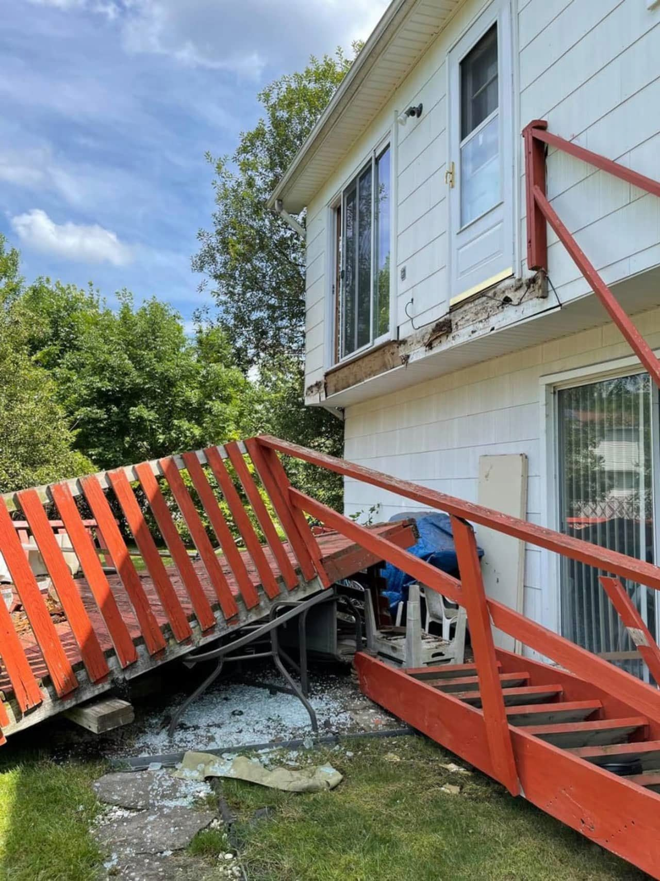

**Exhibit 2**

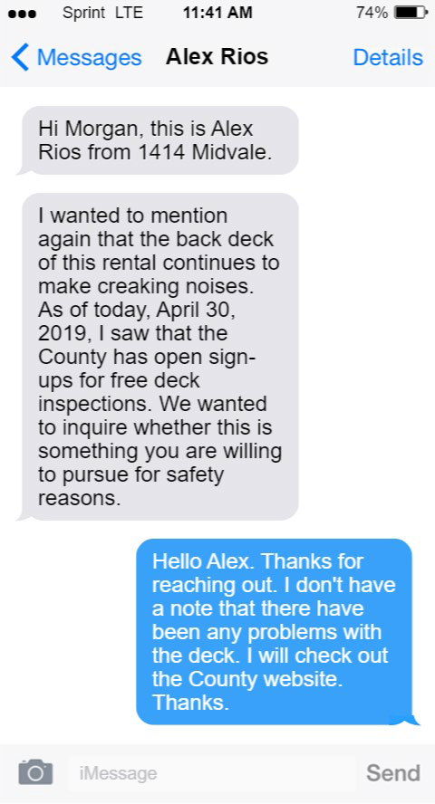

**Exhibit 3**

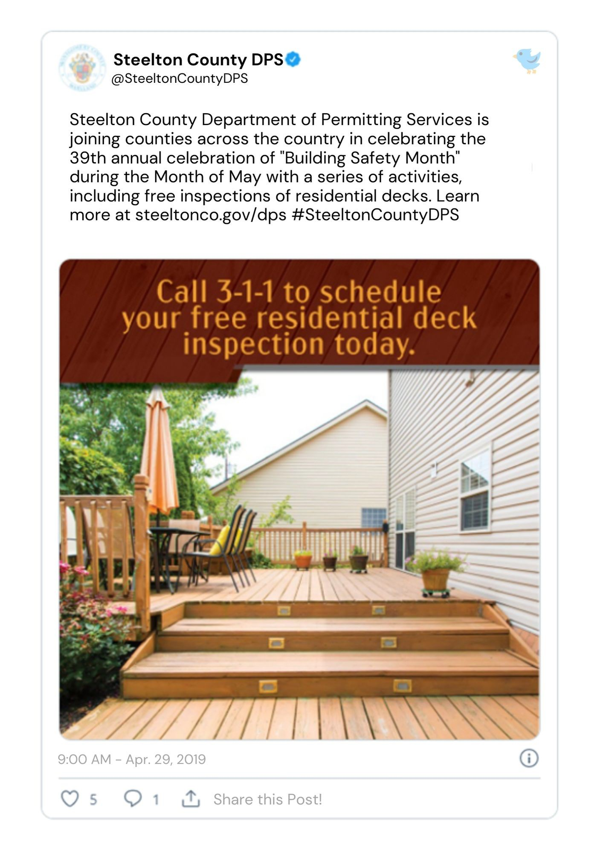

**Exhibit 4**

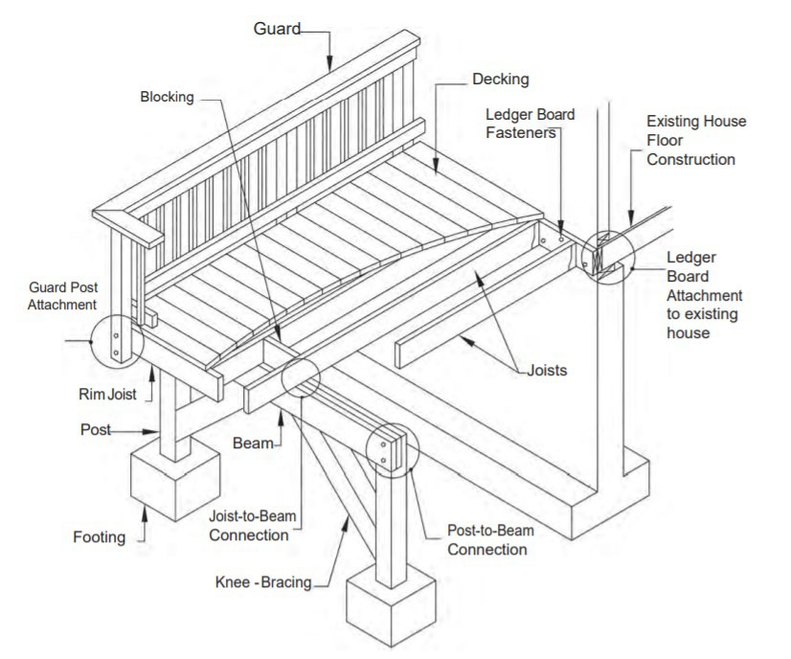

**Exhibit 5**

**DECK MAINTENANCE INSPECTION GUIDELINES**

Maintenance on a deck should be done on a regular basis. It will keep the structure safe and enhance the longevity of the deck itself. Below is a checklist of suggestions that should be done at least once a year to minimize degradation of the deck itself and enhance your enjoyment of a well-maintained deck. **Most decks only last between 15-25 years**, possibly more depending on your environmental conditions. With regular maintenance, you can extend the life of your deck. We hope these suggested guidelines help you with the maintenance of your deck.

# Wood Components

* Visibly check the integrity of all the wood components of your deck. Use a screwdriver and try to penetrate the wood. Check decking boards, floor joists, guardrail posts, handrails, and stair stringers and treads. Use the screwdriver to probe the wood at all intersections, for example, the joists directly under the decking boards. If the wood feels soft or spongy or flakes out with the screwdriver, replace that wood portion of the deck.
* Check stair stringers at the ground and below the treads for rot. Replace as necessary. Any wood-to-wood connection point can hold water and increase degradation.
* Check support posts at grade level. This is an especially vulnerable area due to the wet to dry conditions at grade level. Replace as necessary.

# Ledger Attachment

* Check the ledger attachment and installation. Most catastrophic collapses happen at the ledger to house connection. Decks should not be ledgered to a cantilevered floor system, which is a floor that sticks out past the foundation or supporting wall below. Verify properly installed flashing and proper number of fasteners. If possible, check your house band from the inside of the house. Look for dark stains indicating water is finding a route to the band board. Improperly installed flashing and ledger bolts can let water get to the house band board.
* If you cannot verify attachment method, a free-standing deck may be in your best interest to prevent a deck failure. A post-and-beam configuration is a simple solution for a ledger connection you feel is unsafe. A permit would be required for this new installation.

# Guardrails

* Guardrails should be tested for lateral stability. Any notched or rotted guardrail post or picket should be replaced.
* Older decks may not meet today’s standards for guardrail opening limitations of 4”. Consider adding pickets to the guardrails so that they meet today’s standards.

# Fasteners

* Check all fasteners in the deck. Tighten all nuts and bolts. Look for popping nails and drive all nails that have been raised off the surface of the deck boards.
* Corroded fasteners and joist hangers should be replaced.

# Stairs

* Stair systems should also be thoroughly inspected to ensure safety. Check the integrity of the stair stingers. Look for cracks in the wood along the direction of the grain as this can indicate a shear failure. Look for rot under treads and at the bottom of the stringers where they contact ground. Replace stingers as necessary.
* Any stain stringer consisting of 4 or more risers should have a handrail mounted between 34” and 38” measured vertically from the tread nosing. Return the ends of the handrails to the guard.
* Open risers must meet today’s guardrail opening limitations. If you have open risers, consider closing them to bring into compliance.
* If the triangle formed by the stair tread, rise, and bottom chord of the guard allows the passage of 6” or more, consider closing this opening to bring into compliance.

# Cleaning and Sealing

* Regular cleaning and sealing can not only extend the life of your deck, but it also can make it more aesthetically pleasing. It is also essential to prevent mildew, which can create a slipping hazard. And any accumulation of leaves can rot and speed up deck deterioration.
* Power washing is a great way to clean a deck. But power washing done improperly can bring out the coarse grain of wood in your deck boards, which may increase the chance of splinters. If this happens, sand the deck, and apply a coat of sealant.

# Exhibit 6

**RESIDENTIAL LEASE AGREEMENT**

**THIS LEASE AGREEMENT**, hereinafter known as the “Lease” is entered into this 30th day of May, 2017, by and between **Knight Property Management, LLC**, with mailing address of 43881 Main Street, Steelton 12345, acting as property manager on behalf of property owner, Mickey Terranova, hereinafter known as the “Landlord” and **Thomas Jordan, Alex Rios, and Taylor Williams**, hereinafter known as the “Tenants.”

**WHEREAS** the Landlord desires to lease the Property defined herein under the terms and conditions as set forth herein; and,

**WHEREAS** the Tenants desire to lease the Property defined herein from the Landlord under the terms and conditions set forth herein for their sole and exclusive use.

**NOW THEREFORE**, for an in consideration of the covenants and obligations contained herein and other good and valuable consideration, the receipt and sufficiency of which is hereby acknowledged, the parties hereby agree as follows:

**PROPERTY**: The Landlord, by and through the property owner, owns property and improvements located at 1414 Midvale Avenue, Steelton 12345, referred to as the “Property”

**LEASE TERM**: This Lease shall commence on the June 1, 2017, and shall end on May 31, 2019, hereinafter referred to as the “Term,” unless otherwise terminated in accordance with the provisions of the Lease. Upon the end of the Term, Tenants shall vacate the Property and deliver the same to the Landlord, unless:

1. The Lease is formally extended by the Landlord and the Tenants in writing, signed by both parties, or
2. The Landlord willingly accepts Rent, as defined in this Lease, from the Tenants for a period beyond the original Term. Where the Landlord accepts Rent for a period beyond the original Term, without a formal extension of the Lease in writing and signed by both parties, a month-to-month tenancy will be created.

**RENT**: The Tenants shall pay to Landlord the sum of **$3,000.00 per month** (hereinafter referred to as “Rent”) for the duration of the Term of the Lease. The Rent shall be payable on or before every **1st day of the month** (hereinafter referred to as the “Due Date,” notwithstanding that said date falls on a weekend or holiday.

1. **Late Rent.** If Rent is not paid within five days of the Due Date, Rent shall be considered past due and a late fee of $100 shall be applied for every day the Rent is late.
2. **Returned Checks.** In the event that a check intended as payment for Rent is dishonored for whatever reason, the same shall be considered as Late Rent with the late fee being payable on the same schedule.
3. **Rent Increases.** The Rent payable shall not be increased or otherwise modified during the Term of this Lease. Any increase in Rent shall only take effect after the expiration of the Term provided in this Lease. Any increase in Rent to take effect upon renewal or extension of the Term of this Lease must be preceded by a 30-day notice of the same from the Landlord to the Tenant.

**SECURITY DEPOSIT**: The Tenants shall provide the Landlord with the amount of one- month’s rent upon execution of this Lease as a Security Deposit. The Security Deposit shall be returned upon the termination of the Lease Term in accordance with the laws of the jurisdiction of Steelton.

**SUBLETTING**: Subletting is not allowed, and this Lease is non-transferrable. Tenants shall not sublet, sublease, or otherwise grant any other party any license or right in relation to the Property.

**RIGHT OF ENTRY**: The Landlord shall have the right to enter the interior of the Property during normal working hours by providing at least two hours’ notice in order for inspection, to make necessary repairs or improvements, and to supply services as agreed or for any reasonable purpose. The Landlord shall have the right to enter the exterior yard of the Property **at any time**, including any external structures, such as a deck or shed.

**ALTERATIONS AND IMPROVEMENTS**: Tenants shall make no alterations or improvements to the Property. All repairs and maintenance shall be completed by the Landlord, only. In all cases of unauthorized alterations or improvements shall become the Landlord’s property.

**MAINTENANCE, REPAIR, AND RULES**: For the entirety of the term of this Lease, the Tenants shall keep the property clean and in good repair. This includes, but is not limited to, complying with all local rules, ordinances, and regulations, disposing of any and all waste properly, and not obstructing any structure intended for ingress, egress, or passage from the property. Minor repairs, servicing, and maintenance of the Property shall be the sole responsibility and expense of the Landlord. Any damage caused by Tenants’ failure to exercise ordinary care or reckless behavior that cannot be attributed to routine wear and tear shall be at the sole expense of the Tenants. Pets are not allowed, and any damage caused by animals shall be repaired by Landlord at the sole expense of the Tenants.

**EARLY TERMINATION**: The Tenants shall have the right to terminate this Lease at any time by providing sixty days’ written notice to the Landlord, along with an early termination fee of **$1,000.00**. During the period for termination, the Tenants will remain responsible for the payment of rent.

**DEFAULT**: In the event that the Landlord breaches any of the terms and conditions of this Lease or any applicable laws, rules, or codes, the Tenants may seek remedies available under the law. In the event that the Tenants breach any of the terms and conditions of this Lease, or any applicable laws, rules, or codes, the Landlord may collect a sum in the amount of three-month’s rent from Tenants.

**SEVERABILITY**. Should and provision of this Lease be found, for whatever reason, invalid or unenforceable, such nullity or unenforceability shall be limited to those provisions. All other provisions herein not affected by such nullity or dependent on such invalid or unenforceable provisions shall remain valid and binding and shall be enforceable to the full extent allowed by law.

**MODIFICATION**: The parties hereby agree that this document contains the entire agreement between the parties and this Lease shall not be modified, changed, altered, or amended in any way except through a written amendment signed by all of the parties hereto.

**ENTIRE AGREEMENT**: This Lease is the complete agreement between the Landlord and Tenants concerning the Property. There are no oral agreements, understandings, promises, or representations between the Landlord and Tenants affecting this Lease. All prior negotiations and understandings, if any, between the parties hereto with respect to the Property shall be of no force or effect and shall not be used to interpret this Lease. No modification or alteration to the terms or conditions of this Lease shall be binding unless expressly agreed to by the Landlord and the Tenants in a written instrument signed by both parties.

**IN WITNESS WHEREOF**, the Landlord and Tenants have executed this Lease on the undersigned date.

Landlord, **Knight Property Management, LLC**:

Signature /s/ Morgan Knight Date: May 30, 2017

Tenant, **Thomas Jordan:**

Signature /s/ Thomas Jordan Date: May 30, 2017

Tenant, **Alex Rios:**

Signature /s/ Alex Rios Date: May 30, 2017

Tenant, **Taylor Williams:**

Signature /s/ Taylor Williams Date: May 30, 2017

# Exhibit 7

**To:** Knight, Morgan ([mknight@kpm.com](mailto:mknight@kpm.com)) **From:** Kim, Lane ([LKim@steelton.gov](mailto:LKim@steelton.gov)) **Date:** 6/1/2020

**Subject:** RE: What is wrong with Pat?

Morgan, you know Pat. Every time I go out to do an inspection, if I don’t find something wrong Pat sends me back until I DO find something wrong. I’m sure there was nothing wrong with that deck, but Pat always needs to find a way to justify Pat’s job and make sure everyone knows that Pat is in charge. I wouldn’t worry about it too much.

Lane Kim

Residential Inspector Steelton County

**To:** Kim, Lane ([LKim@steelton.gov](mailto:LKim@steelton.gov))

**From:** Knight, Morgan ([mknight@kpm.com](mailto:mknight@kpm.com))

**Date:** 6/1/2020

**Subject:** What is wrong with Pat?

Hey Lane,

Long time no see, we need to catch up soon.

So, I had a question. I don’t know if you heard about that deck collapse at one of the properties I manage, but apparently Pat came out to look at it afterwards and is claiming that the deck wasn’t properly attached to the house. How could Pat know that? Pat never inspected the deck prior to the collapse, and there is no way to even tell what screws were there originally or how it was attached to the house before the fall. I just can’t believe that a friend of mine would try to screw me over like this.

You have any insight in to why Pat might be acting like this? I would talk directly to Pat, but I’m so disappointed I might just say the wrong thing and I don’t want to lose a friend.

Anyways, just venting. Hope all is well. Morgan Knight

Knight Property Management, LLC

# Exhibit 8

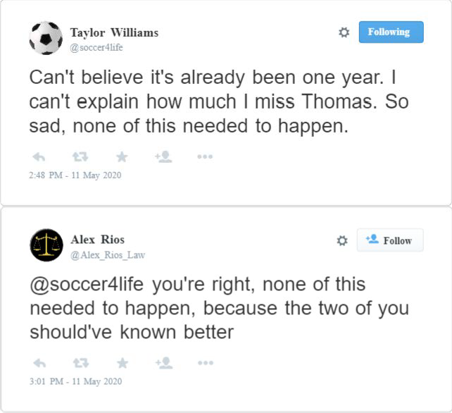

**Exhibit 9**

**To:** Knight, Morgan [(mknight@kpm.com)](mailto:mknight@kpm.com) **From:** Danes, Luke [(luke.danes@gmail.com)](mailto:luke.danes@gmail.com) **Date:** 5/25/2017

**Subject:** Inspection Report

**Attachment: 1414 Midvale Inspection Report**

Morgan,

Here is the inspection report for 1414 Midvale Ave. that you asked to see. As you can see, the inspector didn’t find any issues of note, and doesn’t say anything about any issues with the deck. So, should be all good.

Thanks, and let me know if you need anything else! Luke Danes

# Exhibit 10

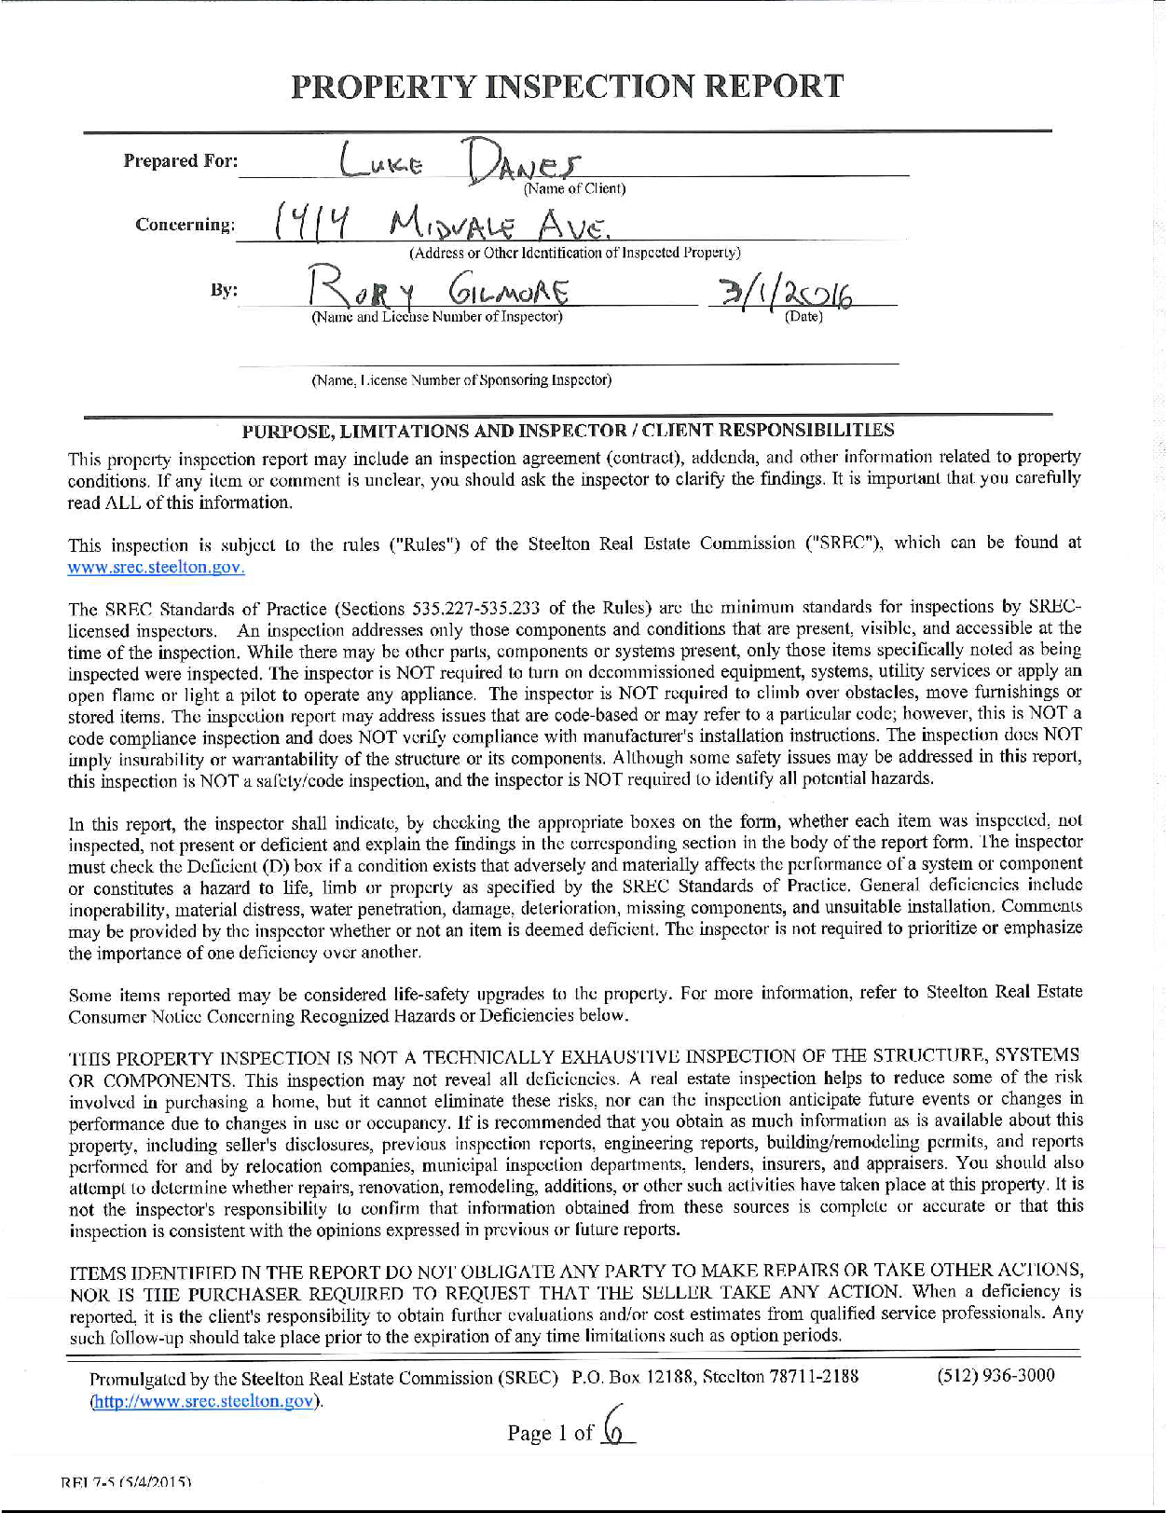

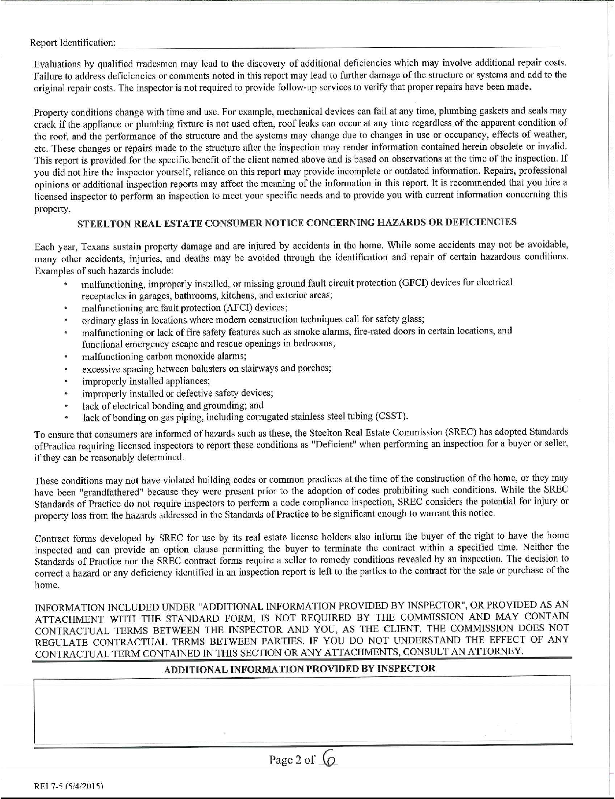

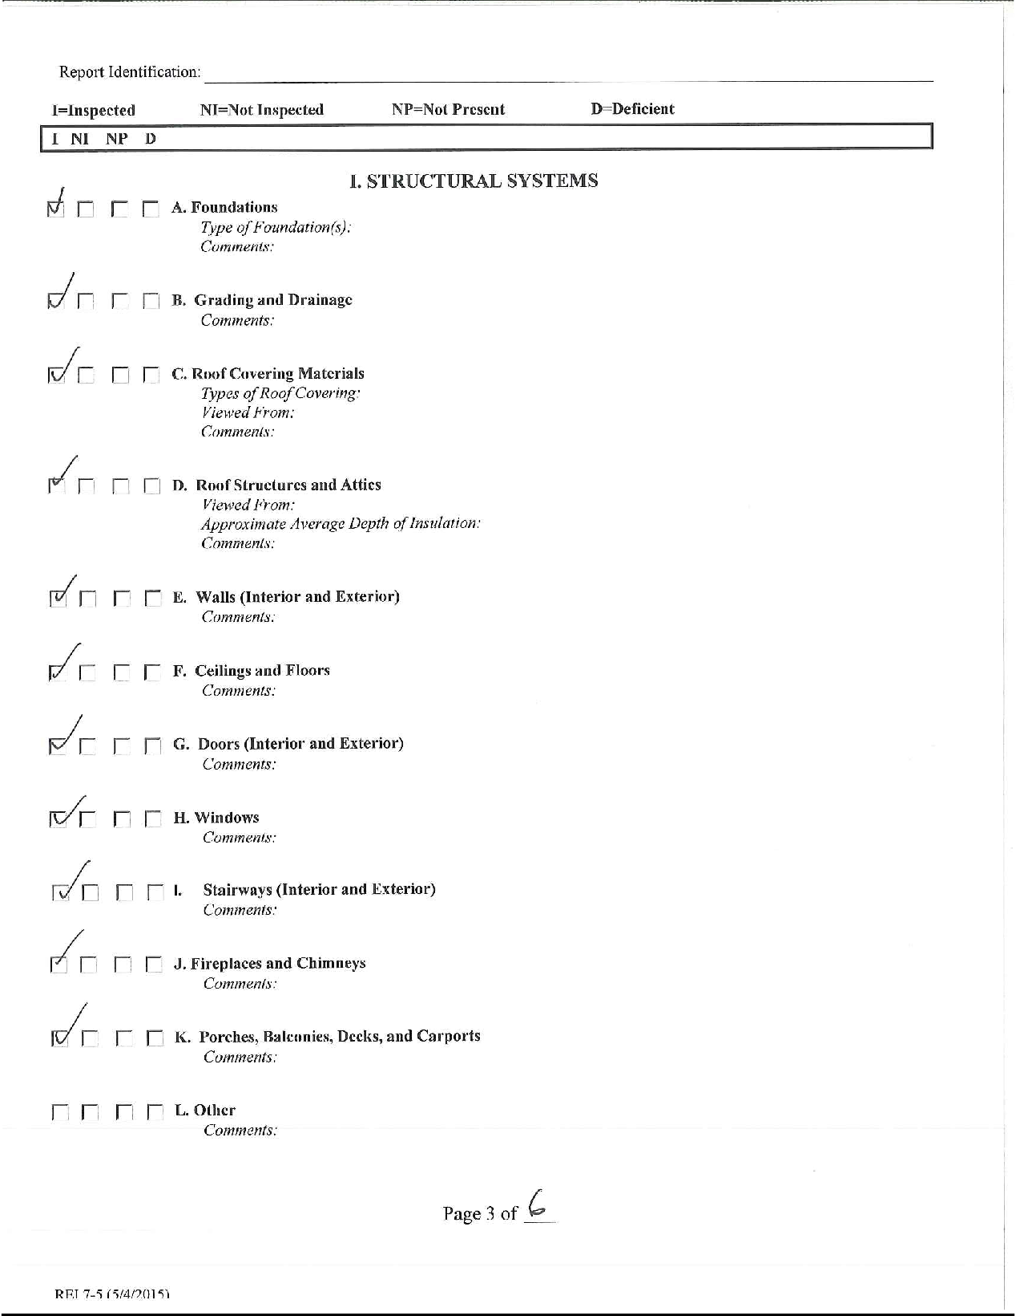

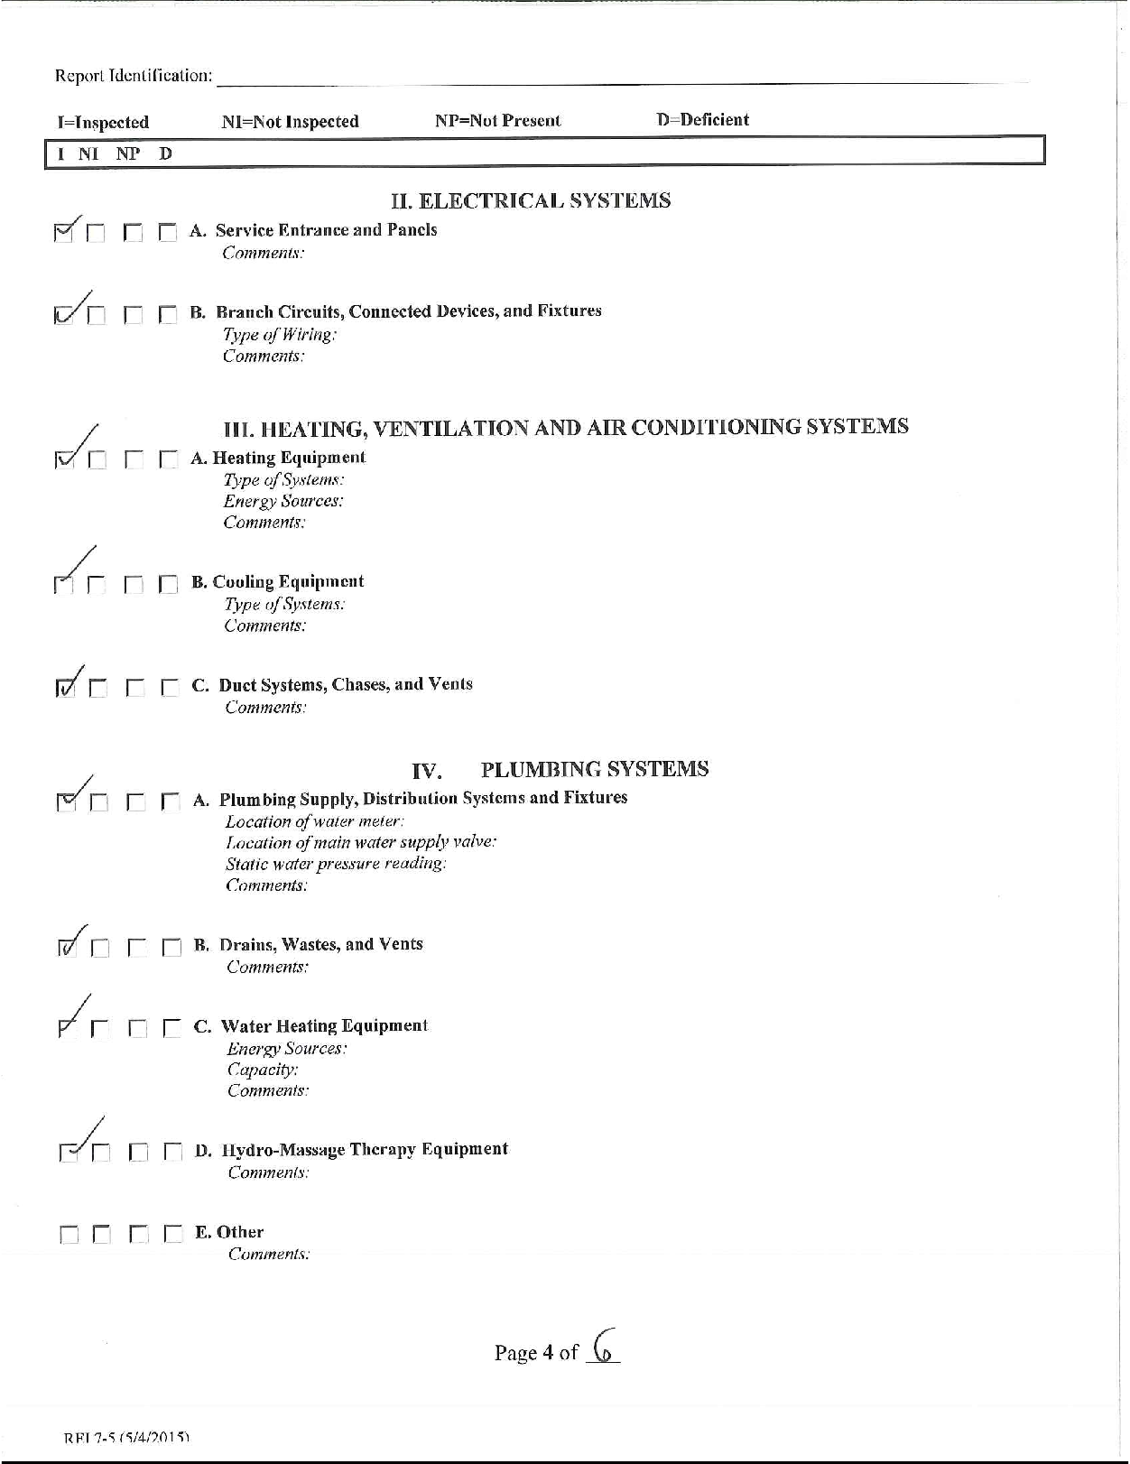

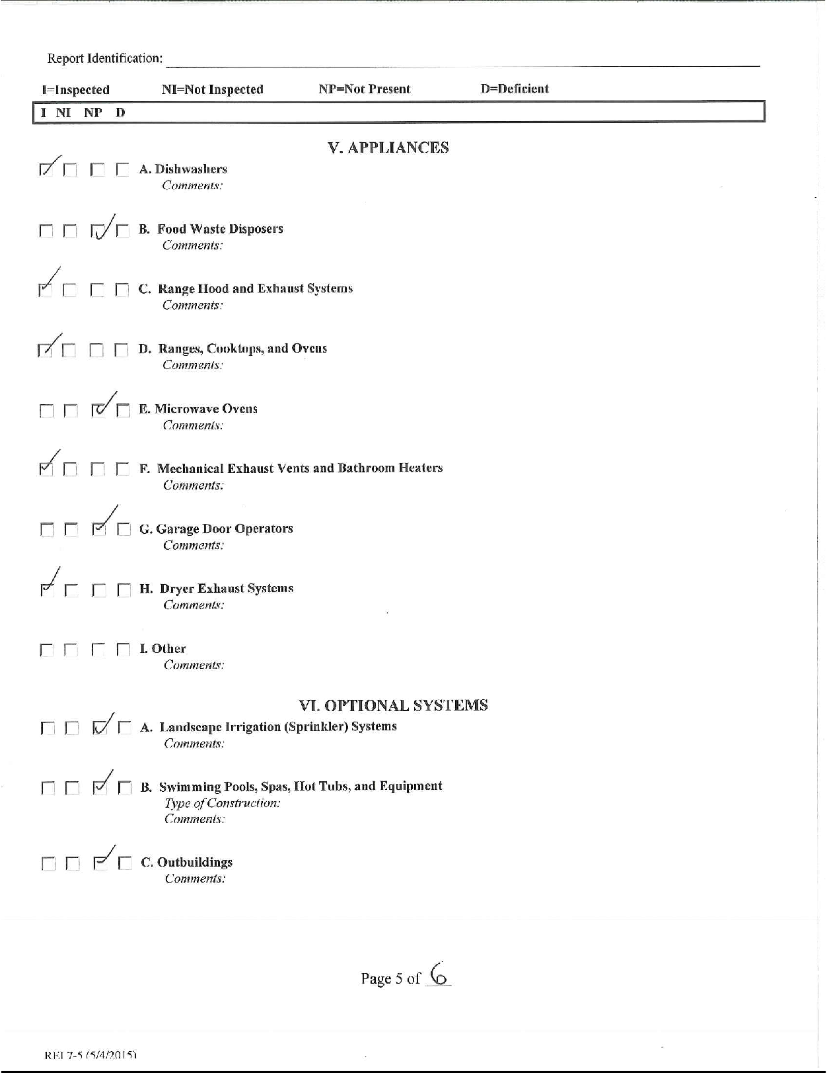

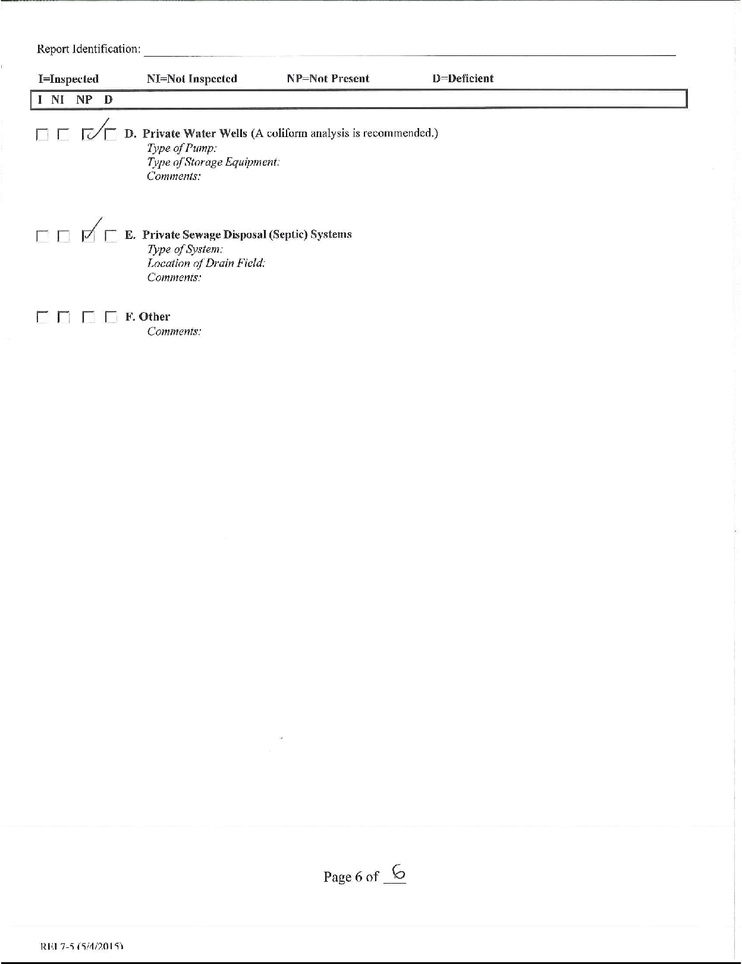

**JURY INSTRUCTIONS**

I shall now instruct you on the law that you must follow in reaching your verdict. It is your duty as jurors to decide the issues, and only those issues, that I submit for determination by your verdict. In reaching your verdict, you should consider and weigh the evidence, decide the disputed issues of fact, and apply the law to the facts as you find them, from the evidence.

# IMPARTIALITY IN CONSIDERATION

You must consider and decide this case fairly and impartially. All persons, including corporations, stand equal before the law and are entitled to the same treatment under the law. You should not be prejudiced for or against a person because of that person's race, color, gender, religion, political or social views, wealth, or poverty. You should not even consider such matters. The same is true as to sympathy for any party.

# QUESTIONS OF LAW DURING TRIAL

During the course of the trial, it has been my duty to rule on a number of questions of law, such as objections to the admissibility of evidence, the form of questions, and other legal points. You should not draw any conclusions from these rulings either as to the merits of the case, or as to my views regarding any witness, party, or the case itself.

It is the duty of a lawyer to make objections that the lawyer believes are proper. You should not be influenced by the fact that these objections were made, no matter how the court may have ruled on them. You must disregard any evidence which I have ordered stricken. If I sustained an objected to any question, you must not speculate about what the answer might have been.

# WITNESS TESTIMONY CONSIDERATION

Any person who testifies, including a party, is a witness. You are the sole judges of whether testimony should be believed. In making this decision, you may apply your own common sense and everyday experiences.

In deciding whether a witness should be believed, you should carefully consider all the testimony and evidence, as well as whether the witness's testimony was affected by other factors. You should consider such factors as:

1. the witness's behavior on the stand and way of testifying;
2. the witness's opportunity to see or hear the things about which testimony was given;
3. the accuracy of the witness's memory;
4. whether the witness had a motive not to tell the truth;
5. whether the witness had an interest in the outcome of the case;
6. whether the witness's testimony was consistent;
7. whether the witness's testimony supported or contradicted other evidence, and
8. whether and the extent to which the witness's testimony in the court differed from statements made by the witness on any previous occasion.

You are the sole judges of whether a witness should be believed. You need not believe any witness even though the testimony is uncontradicted. You may believe all, part, or none of the testimony of any witness.

# WHAT CONSTITUTES EVIDENCE

In making your decision, you must consider the evidence in this case. What constitutes evidence includes:

1. testimony from the witness stand; and
2. physical evidence or exhibits admitted into evidence; and
3. stipulations read to the jury.

In evaluating the evidence, you should consider it in light of your own experiences. You may draw any reasonable conclusion from the evidence that you believe to be justified by common sense and your own experiences.

Objections of the lawyers are not evidence, and you should not give them any weight or consideration.

You must not consider exhibits that I did not admit into evidence or testimony that I ordered be stricken. You must disregard questions that I did not permit the witness to answer, and you must not speculate as to the possible answers. If after an answer was given, I ordered that the answer be stricken, you must disregard both the question and the answer.

Opening statements and closing arguments of lawyers are not evidence. They are intended only to help you understand the evidence and to apply the law. Therefore, if your memory of the evidence differs from anything the lawyers or I may say, you must rely on your own memory of the evidence.

# BURDEN OF PROOF-PREPONDERANCE OF EVIDENCE STANDARD

The party who asserts a claim or affirmative defense has the burden of proving it by what we call the preponderance of the evidence. In order to prove something by a preponderance of the evidence, a party must prove that it is more likely so than not so. In other words, a preponderance of the evidence means such evidence which, when considered and compared with the evidence opposed to it, has more convincing force and produces in your minds a belief that it is more likely true than not true.

In determining whether a party has met the burden of proof you should consider the quality of all of the evidence regardless of who called the witness or introduced the exhibit and regardless of the number of witnesses which one party or the other may have produced.

If you believe that the evidence is evenly balanced on an issue, then your finding on that issue must be against the party who has the burden of proving it.

# NEGLIGENCE

The issue for your determination in this matter is whether Knight Property Management, LLC was negligent in failing to protect the decedent, Thomas Jordan, and if so, whether such negligence was the proximate cause of Thomas Jordan’s death.

The term “negligence” as used in these instructions means the failure to use that degree of care that an ordinarily careful and prudent person or business would use under the same or similar circumstances. The law does not say how a reasonably careful person or business would act under those circumstances. That is for you, as the fact finders, to decide.

“Ordinary care” means the care a reasonably careful person or company would use under circumstances similar to those shown by the evidence. The law does not say how a reasonably careful person would act under those circumstances. That is for you to decide.

“Proximate cause” is an act or failure to act which, in the natural continuous sequence, was a substantial factor in producing the injury, and without which it would not have occurred. Proximate cause occurs when the injury is the natural and foreseeable result of the act or failure to act.

A “Substantial Factor” in causing harm is a factor that a reasonable person would consider to have contributed to the harm. It must be more than a remote or trivial factor. It does not have to be the only cause of the harm. Conduct is not a substantial factor in causing harm if the same harm would have occurred without that conduct. However, a party cannot avoid responsibility just because some other person, condition, or event was also a substantial factor in causing harm. There can be multiple substantial factors in causing harm.

In order to establish negligence on the part of Knight Property Management, LLC, the plaintiff had to prove that:

1. Knight Property Management, LLC had a duty to provide a safe living environment by using ordinary care for the safety of the premises it managed;
2. Knight Property Management, LLC breached or failed their duty by doing something a reasonably careful person would not do or failing to do something a reasonably careful person would do;
3. Knight Property Management, LLC’s acts or failures to act were substantial factors in producing the death of Thomas Jordan and without which decedent’s death would not have occurred.
4. The Plaintiff, as a wrongful death beneficiary, received injury in fact upon the death of Thomas Jordan. It is not your determination at this time the extent of injury or damage to the plaintiffs, rather, whether there was in fact an injury.

# VICARIOUS LIABILITY

Knight Property Management, LLC is a limited liability company. A company is liable for all damages proximately caused by the negligence of the company’s employees and owners, while acting within the scope of that person’s employment or ownership. In reaching your decision whether Morgan Knight was acting within the scope of Morgan Knight’s employment or ownership, you must determine whether they were acting within the ordinary course of such business.

# LANDLOR-TENANT DEFINITIONS

A “residential landlord” is defined as any property owner of, or any person or company hired by a property owner to perform property management of, an apartment complex or other residential rental building for a residential tenancy.

“Residential tenancy” means a tenancy that is based on a rental agreement between a property owner and a tenant for a dwelling unit.

“Tenant” means a person entitled only under the terms of a rental agreement to occupy a dwelling unit to the exclusion of others.

# NOTICE OF UNSAFE RENTAL PROPERTY CONDITIONS

A residential landlord will be deemed to have actual knowledge if he or she knew of an unsafe condition upon personal inspection or notice provided by a tenant.

A residential landlord will be deemed to have constructive notice of an unsafe condition if, upon reasonable inspections, the landlord would have discovered the unsafe condition.

# DUTIES OF A RESIDENTIAL LANDLORD DURING THE PENDENCY OF A RESIDENTIAL TENANCY

A residential landlord has a duty to keep a unit in a safe and habitable condition and in good repair. A residential landlord must:

* 1. maintain the building structure;
  2. keep electric, heating and plumbing in working order; and,
  3. exercise ordinary care to keep the unit and access safe for tenants.

A residential landlord has a duty to use reasonable care to make repairs for which the residential landlord has actual or constructive notice.

A property manager may be held liable for dangers caused by lapses in maintenance for which a reasonable residential landlord would have actual or constructive notice.

# AFFIRMATIVE DEFENSES

Knight Property Management, LLC has asserted affirmative defenses. The defense did not and does not have to pursue all of these affirmative defenses. To be successful, the defense had to establish each affirmative defense by a preponderance of the evidence.

# AFFIRMATIVE DEFENSE – COMPARATIVE NEGLIGENCE

Knight Property Management, LLC claims that the decedent’s own negligence contributed to his harm. To succeed on this claim, Knight Property Management, LLC had to prove both of the following:

1. That decedent was negligent; and
2. That decedent’s negligence was a substantial factor in causing his harm.

If Knight Property Management, LLC proved the above, Plaintiff’s damages are reduced by your determination of the percentage of decedent’s responsibility. Your only job is to provide the percentage of negligence you attribute to decedent’s own conduct on the verdict form, where asked.

# AFFIRMATIVE DEFENSE – ASSUMPTION OF THE RISK

If you find by the greater weight of the evidence that the plaintiff fully understood the nature and extent of a known danger, and if he voluntarily exposed himself to it, he assumed the risk of injuring himself from that danger. The plaintiff cannot recover for injuries that proximately resulted from assuming the risk of a known danger. The Defendant must prove by a preponderance of the evidence that: (1) the Plaintiff fully understood the nature and extent of a known danger; and (2) the Plaintiff voluntarily exposed himself to such danger.

# AFFIRMATIVE DEFENSE – PROXIMATE CAUSE – SUPERSEDING CAUSE

A superseding cause is a new independent cause that breaks the chain of proximate causation between a defendant’s negligence and an injury.

If, however, you find that the Defendant was negligent and that in the exercise of ordinary care, the Defendant should reasonably have anticipated the later independent intervening cause, then that cause does not supersede defendant’s original negligence and you may find that the Defendant’s negligence was a proximate cause of the decedent’s death.

# IN THE CIRCUIT COURT FOR STEELTON COUNTY

**CHRIS JORDAN AS THE PERSONAL * REPRESENTATIVE OF THE ESTATE OF THOMAS JORDAN \***

*Plaintiff* *

v. * Civil Case No. 19-CV-1014

# KNIGHT PROPERTY MANAGEMENT, LLC *

*Defendant* *

# VERDICT FORM

Your verdict must be based on the facts as you find them and, on the law, contained in the Court’s jury instructions. The issues in this case are:

**WRONGFUL DEATH:** On these issues, the Plaintiff has the burden of proof.

# Was the Defendant, Knight Property Management, LLC negligent?

**Yes No**

If you answered “Yes” to Question 1, go to Question 2.

If you answered “No” to Question 1, you are done. Do not answer any further questions.

# If Defendant was negligent, was Defendant’s negligence a

**proximate cause of Plaintiff’s Decedent’s death? Yes No**

If you answered “Yes” to Question 2, go to Question 3.

If you answered “No” to Question 2, you are done. Do not answer any further questions.

**COMPARATIVE NEGLIGENCE:** On these issues, the Defendant has the burden of proof.

# Was the Plaintiff’s Decedent, Thomas Jordan negligent?

**Yes No**

If you answered “Yes” to Question 3, go to Question 4. If you answered “No” to Question 3, go to Question 6.

# If Plaintiff’s Decedent, Thomas Jordan was negligent,

**was his negligence a proximate cause of his own death?**

**Yes No**

If you answered “Yes” to Question 4, go to Question 5. If you answered “No” to Question 4, go to Question 6.

# What percentage of responsibility do you find for:

**Plaintiff’s Decedent + Defendant** = 100%

Go to Question 6.

**ASSUMPTION OF RISK:** On these issues the Defendant has the burden of proof.

# Did the Plaintiff’s Decedent, Thomas Jordan assume the risk of his injuries, including death?

If you answered “Yes” to Question 6, go to Question 7. If you answered “No” to Question 6, you are done.

# Yes No

1. **If Plaintiff’s Decedent, Thomas Jordan assumed the risk**

**of his injuries, was this the proximate cause of his death?**

**Yes No**

You are done. Please sign and return to the Judge.

Jury Foreperson